GPS/GSM Personal Tracking Device

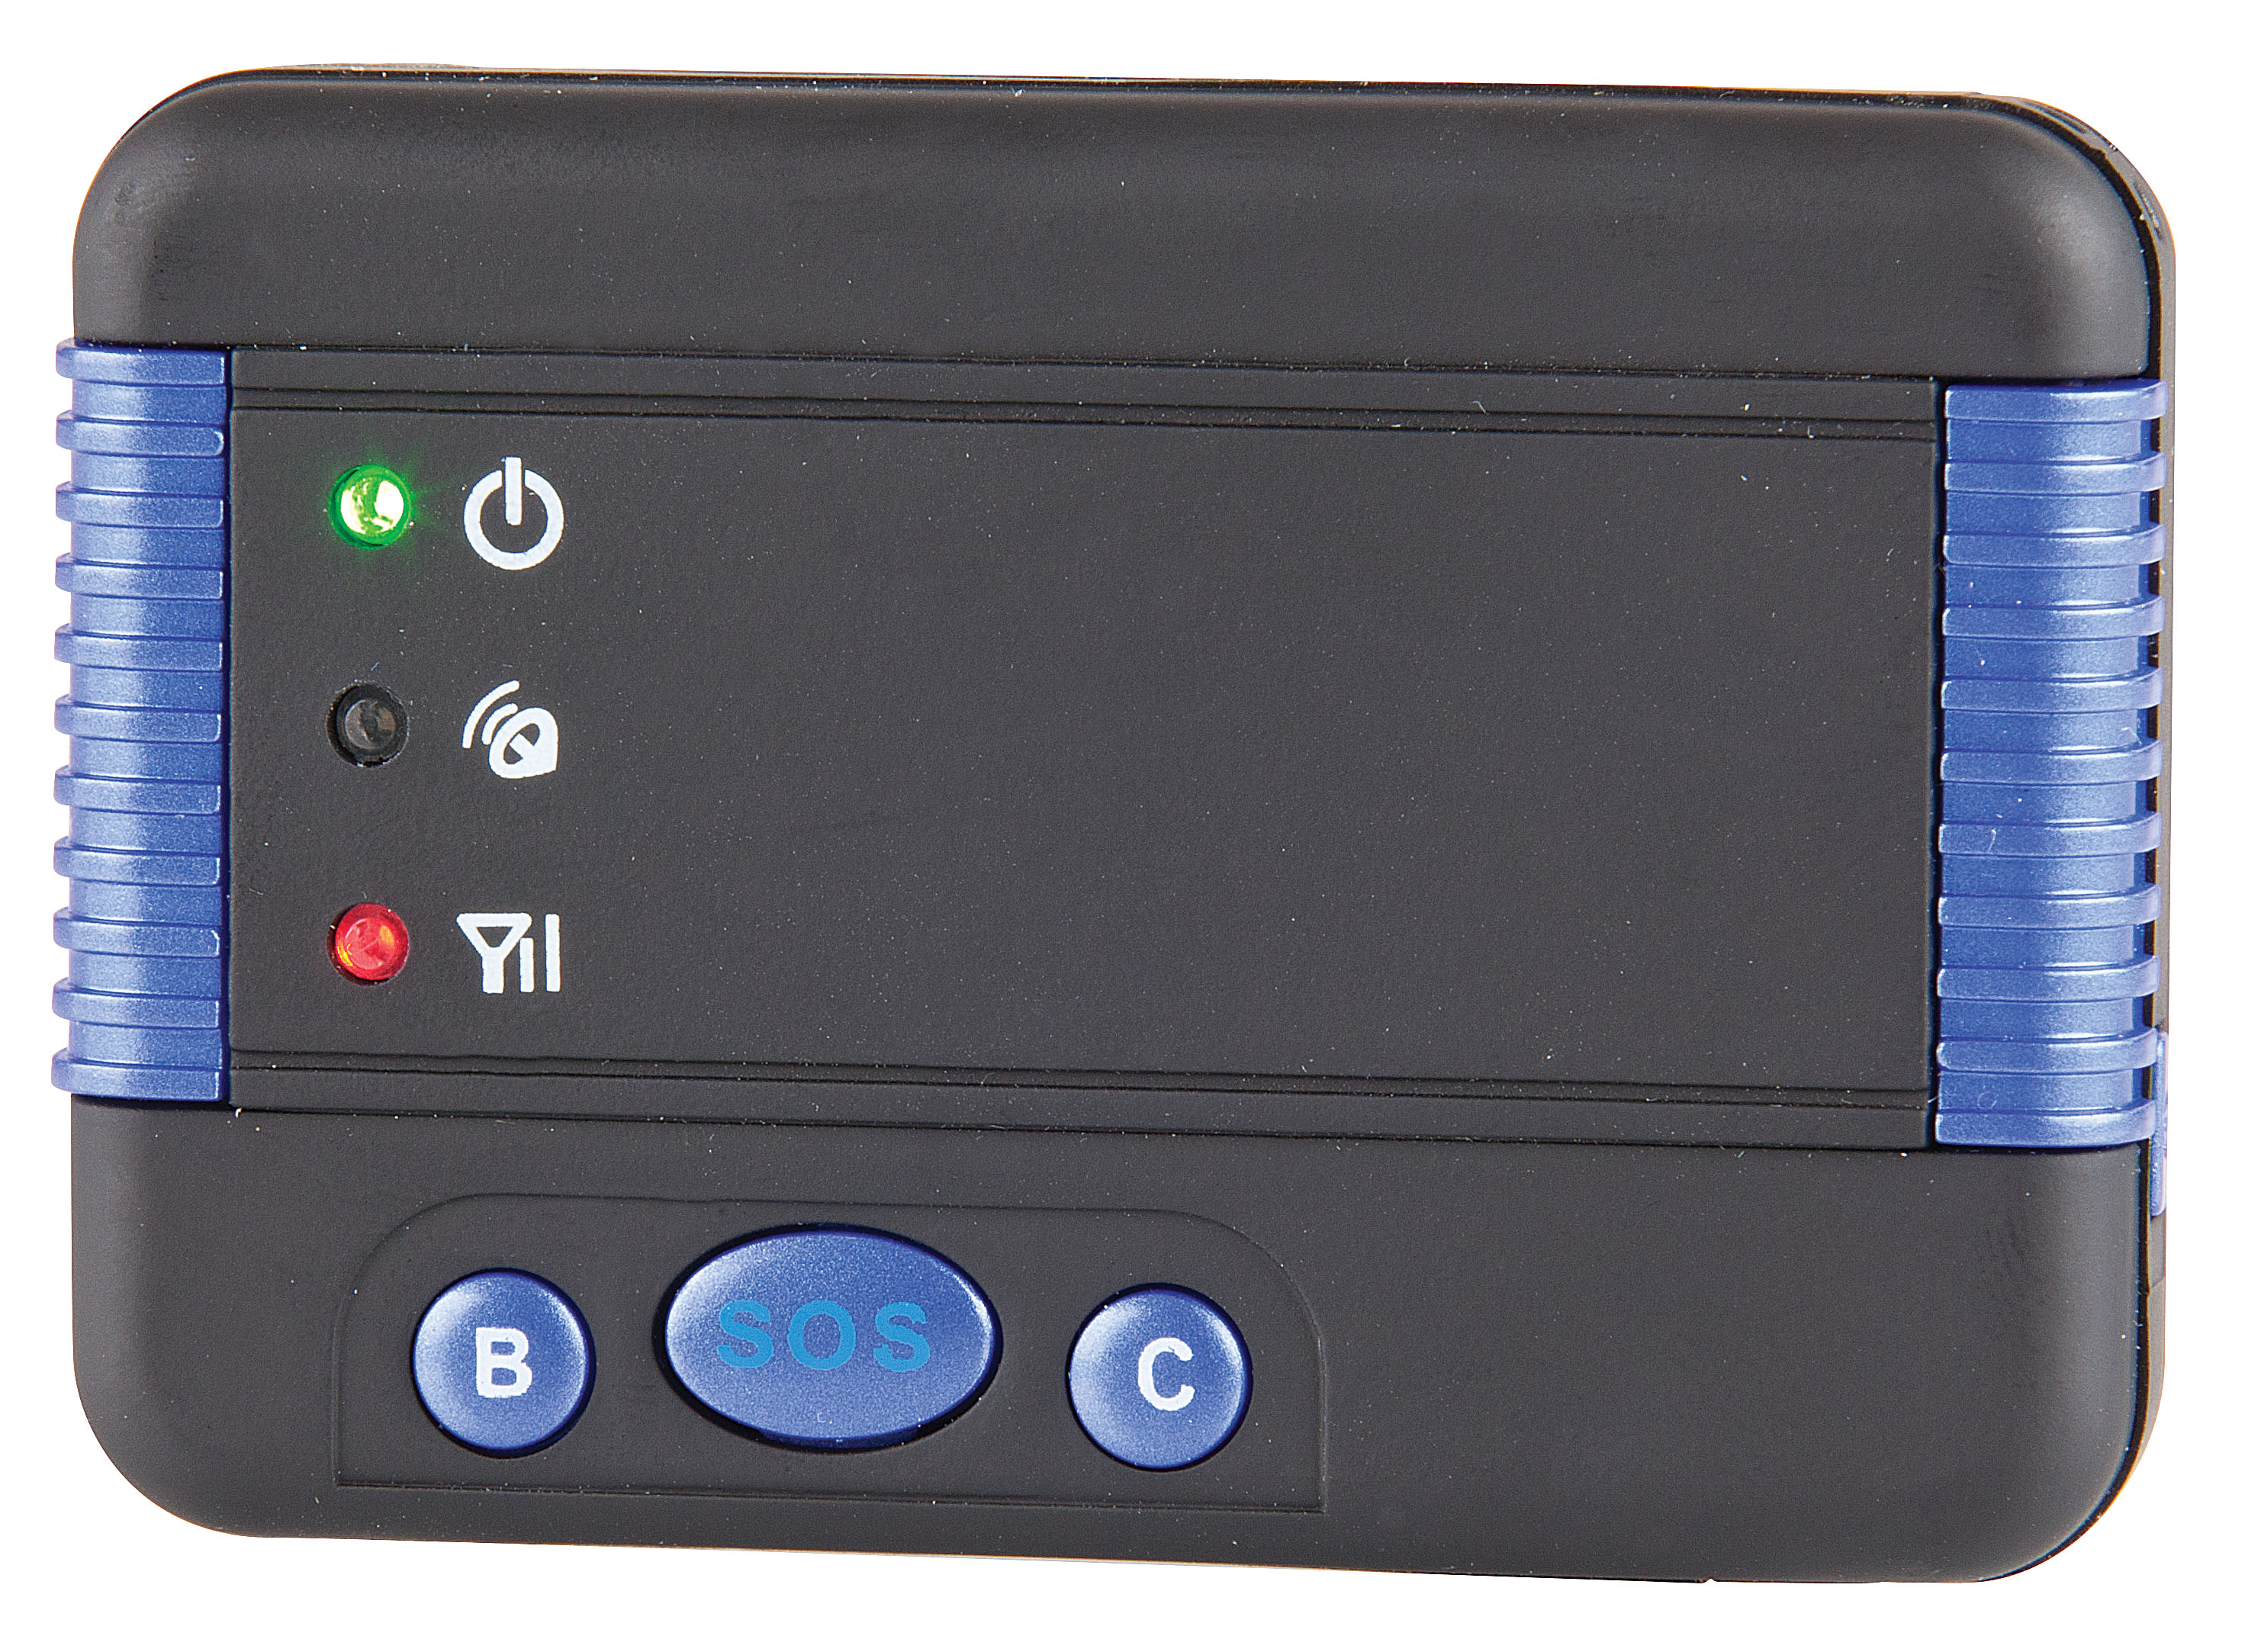

User Manual

INDEX
- Usage
- Packing list
- Before using
- Add/Delete/Check Preset Phone Number
- Change / Check Password
- Set langue
- Set SMS locate mode after calling
- Send a SMS trigger SMS locate
- Set website map link locate mode after calling
- Send a SMS trigger website map link locate
- Set move alarm
- Over Area Alarm
- Over Speed Alarm
- Real Tracking Mode
- Cancel All Alarm Setting
- Low Battery Alarm
- Monitor & Listen Sound around tracker
- Call and talk to preset phone
- Set Power Saving mode (Set GPS On Off Interval)
- “SOS”
- Installation Guide
- Notes
- Trouble Shooting
- Instruction List

Usage
- Our free latitude and longitude located website:
http://www.followmegps.com
- Our free link located map website:
http://www.followmegps.mobi
Packing list
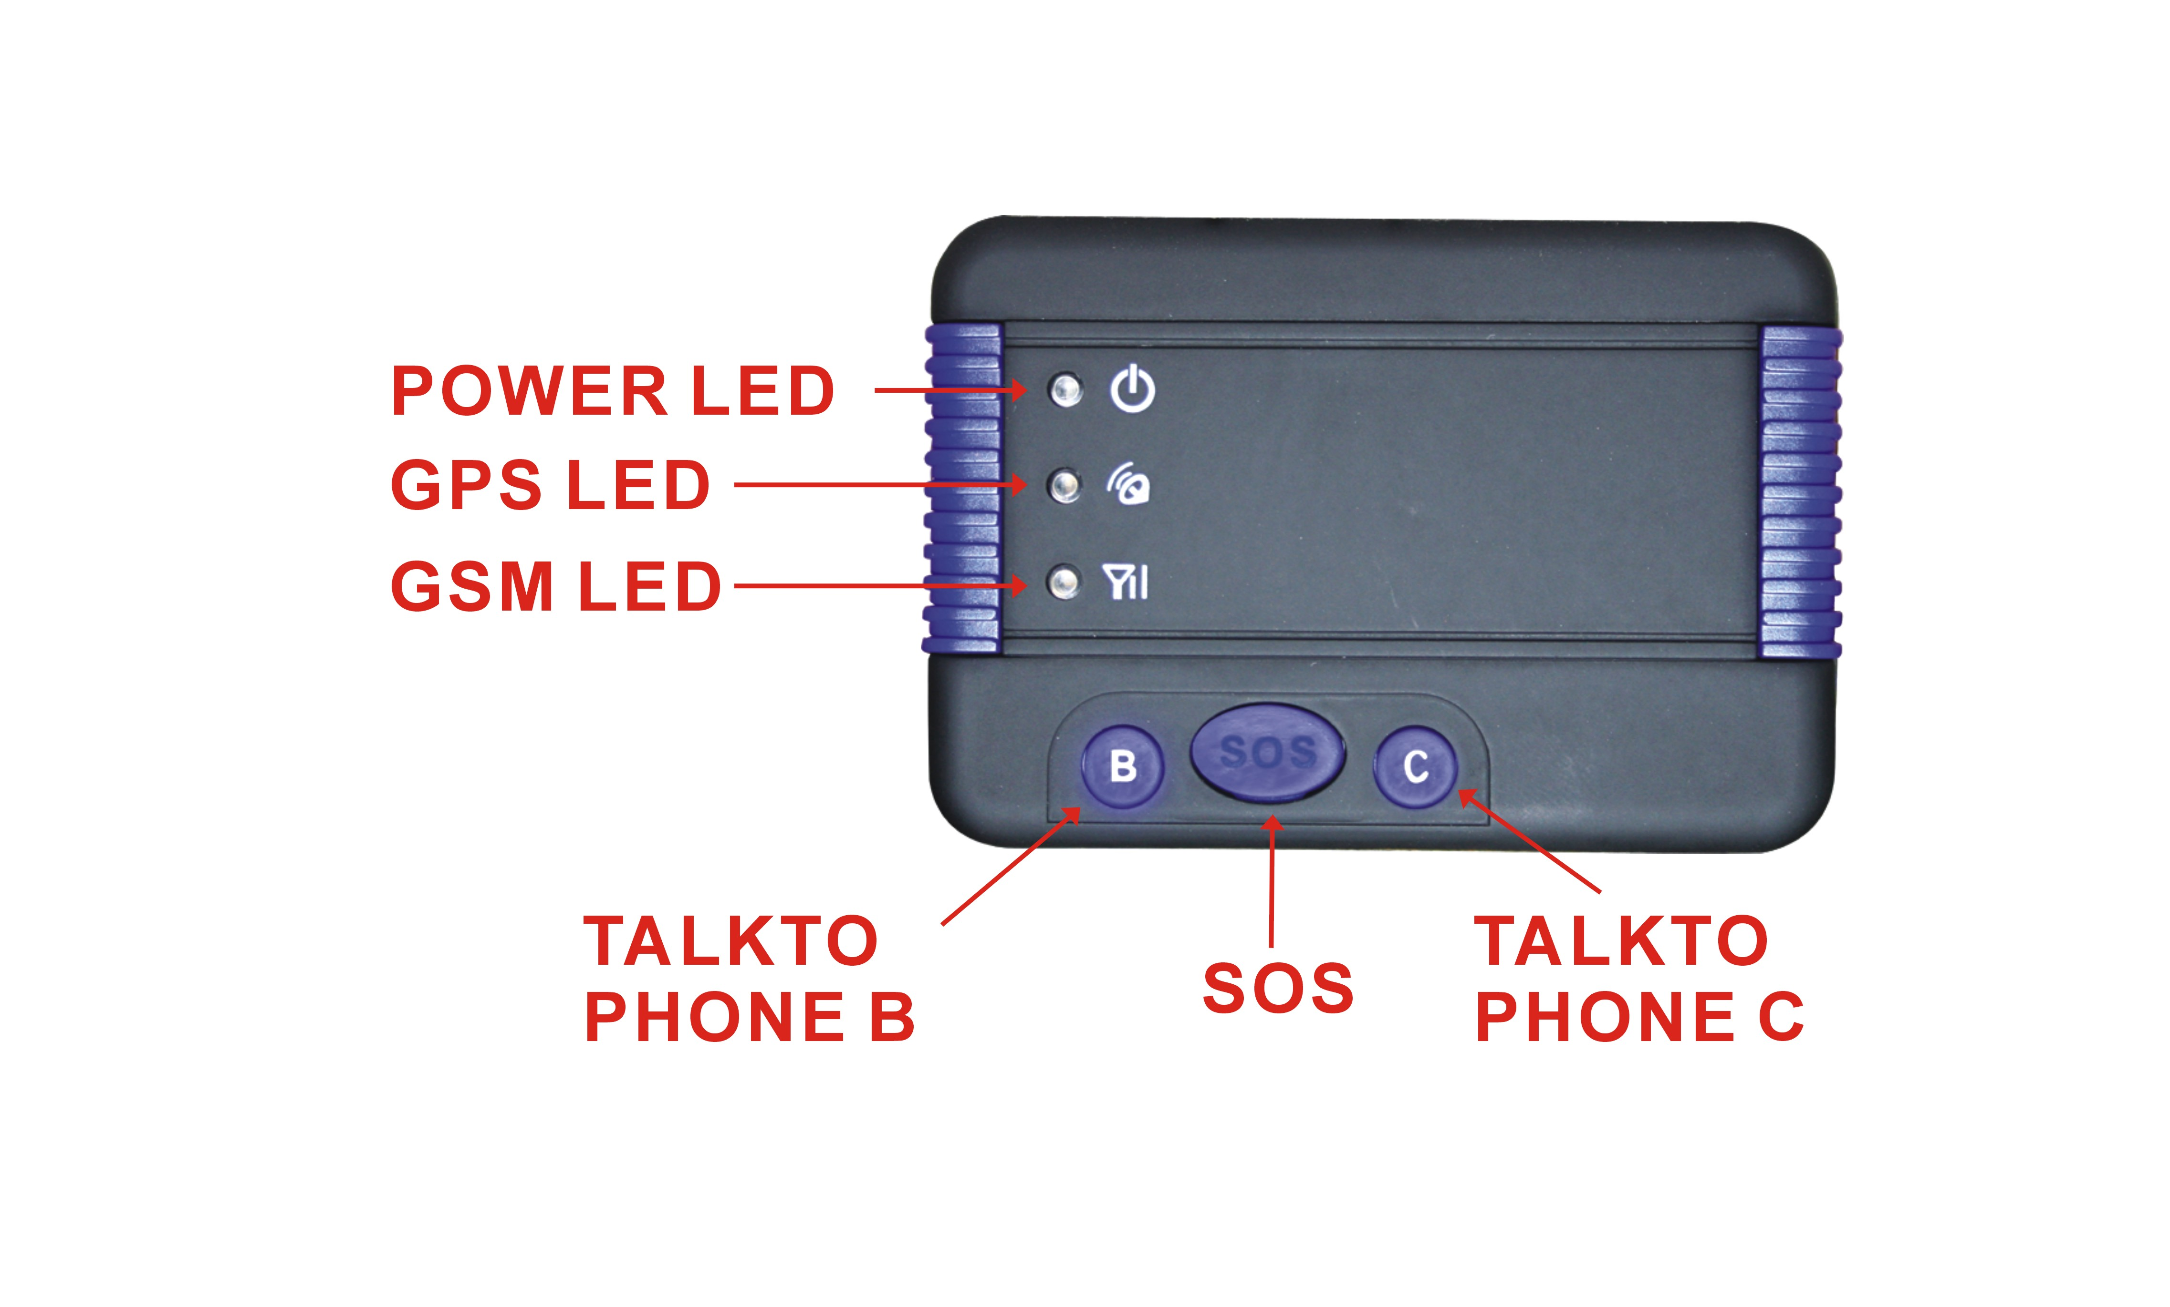
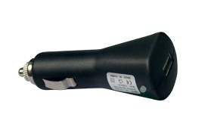
- GPS tracker, car charger, home AC charger, manual.
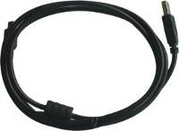

USB Charging Wire Car Adaptor
Before Use
Purchase a GSM phone SIM card which has SMS service and incoming caller ID service, and then to install to the tracker. All operation for this tracker is linked to the number, such as locating immediately, add & delete preset numbers, change password, enable over speed alarm, enable move alarm etc.
Note: This tracker is compatible with 3G SIM cards however it only operates on a 2G band.
- Power ON / OFF
    - When power is OFF, press the “ON/OFF” button untill the LED is ON, then release the button, the tracker is powered ON, when the LED flash means the tracker is working well.
    - When the power is ON, press the “ON/OFF” button till the LED turn off, then release the button, the tracker is powered OFF.
    - When power is OFF, recharge the tracker, the tracker will power on automatically.
    - When the battery voltage in the tracker is too low, the tracker will power off automatically
- Install SIM card: Pull out the battery cover and remove the battery, you can see the SIM card holder under the battery, move the metal cover to another side, you can lift one side of the metal cover, put the SIM card into the holder (Metal pin face down), and make the cover fasten.
Note: Before installing or uninstalling the SIM card, please power off the tracker.
- LED flash indicator
Green Power LED Flash once : working well
Green Power LED Flash twice : GSM working well and GPS signal weak
Green Power LED Flash three times : GSM and GPS working well but battery is low
Green Power LED Flash four times : GSM working well, battery low & no GPS signal
Green Power LED ON continuously : Searching network
Green Power LED OFF continuously : Power off
Blue GPS LED ON : GPS module is ON
Red GSM LED Flash fast : Incoming or making a call or receiving a SMS
- Recharge the tracker
- Warning: this tracker uses 5V DC voltage to recharge, higher voltage or AC voltage may damage the tracker or even cause accidents.
- Use the car adaptor to recharge the tracker: insert the USB cable into the tracker and car adapter, If the LED on the adaptor is RED, it means it is recharging, if the LED on the adaptor is GREEN, it means, it means the recharging is finished. This will take about 2-4 hours.
- When recharging, It will take approx 3-4 hours to finish charging, the car adaptor LED will turn to GREEN, when the battery is low, the LED will flash three times, and send the battery low information to the first preset number. When the battery voltage is too low, the tracker will power off automatically, but when you recharge the tracker, it will power on automatically.
- Back to default settings
Pull out the battery cover and remove the battery, press the “ON/OFF” button and hold on, insert the battery into the tracker, the tracker will power on, after the LED flash 10 times and the LED will turn on continuously, release the button, the tracker will revert back to default settings, delete all preset phone number and password, the password is changed to default: 123456.
- ANTENNA
- The Antenna of GSM and GPS are built in to the tracker.
Using Condition
The working temperature is -20 ⁰C to 60 ⁰C, over this range the specification of the tracker may not function correctly, the storage temperature can reach to -40 ⁰C to 80 ⁰C.
Function Description
Add / Delete / Check preset number:
Preset Phone Number: user can set 3 preset phone number, this number is used as sending SOS help, low battery alarm information and change/check tracker password and trigger the locating by calling, only preset phone number can do these operation.
- Add preset phone number by SMS
Send SMS“ADDPHONE*123456*A*number”(Not including the quotation marks “ and ”, Number means the telephone number you want preset, the following is same) to tracker is OK, “ADDPHONE” is a command; “123456” is password; “A” is preset number location, every tracker have is 3 preset phone number location, A , B and C, so you can preset 3 phone number, if the add operation is success, the tracker will send back the information ”ADDPHONE OK”, if the command or password is not right, the operation fault, the tracker will send back information “ADDPHONE FAIL”.
- Delete preset phone number by SMS
Send SMS “DELETEPHONE*123456*A” to the tracker, “DELETEPHONE” is a command; “123456” is password; “A” is preset phone number location, there is 3 location “A”，“B” and “C”; if the delete operation is success, the tracker will send back the information ”DELETEPHONE OK”, if the command or password is wrong, the operation fault, the tracker will send back information “DELETEPHONE FAIL”.
- Check preset phone number by SMS
Send SMS “CHECKPHONE*123456” to tracker, “CHECKPHONE” is a command; “123456” is password; if the operation is success, the tracker will send back the information “CHECKPHONE A: 13322990998； B： 13322990033； C： 13316868198”, the phone number is just an example.
Change / Check Password
- Change tracker password
Send SMS “CHANGEPASSWORD*123456*888888” to tracker, “CHANGEPASSWORD” is a command; “123456” is old password; “888888” is new password; if the operation is success, the tracker will send the information “ New Password：888888” to every preset phone number, if the operation fail, the tracker will send back information “CHANGEPASSWORD FAIL”.
Note: Only preset phone can change the password.
- Check tracker password
Send SMS “CHECKPASSWORD” to the tracker, “CHECKPASSWORD” is a command, if the operation is success, the tracker will send back the information “Password：888888”; “888888”is an example.
Note: Only preset phone can check the password.
Set Language:
Send SMS “ENGLISH*123456” to the tracker, “ENGLISH” is a command, “123456” is password; if the operation is successful, the tracker will send back the information “ Set Language to English” , If the command or password is not right, the operation is fault, the tracker will send back information “Bad Command ” or “Wrong Password”. After setting the language to english, all the SMS information is change to english, the default langue is english, also you can set the langue to chinese, replace the command “ENGLISH” to “设置中文” is OK.
Set SMS locate mode after calling:
- Send SMS “SMSMODE*123456” to the tracker, “SMSMODE” is a command, “123456” is password; if the operation is success, the tracker will send back the information “ Set Report Mode to SMS” , if the command or password is not right, the operation is fault, the tracker will send back information “Bad Command ” or “Wrong Password”.
Please note that this SMS is just a mode setting command, it will not trigger the tracker locate immediately, Call the tracker or send SMSLOCATE SMS can trigger locate immediately.
- Under this report mode, using preset phone call the tracker, after ringing 3 times, the tracker will hang up the call automatically and locate immediately, about 30 seconds, the tracker will send back the SMS location information (latitude longitude speed battery time etc) of current location to the caller. If the tracker has not preset number, any phone call can trigger the tracker to locate immediately and send back location, if the tracker has preset number, then only preset phone call can trigger the tracker to locate immediately.
- Basic Location information including Latitude, Longitude, Speed, Direction, Date & Time, Battery etc. the SMS information sample is as follow:
Latitude:22.680206N
Longitude:114.146998E
Speed(km/h):45.0
Direction(Degrees):303.30
GMT:2008/04/25 08:29:06.000
Battery:91%
The first line is the latitude of the tracker.
The second line is the longitude of the tracker.
The third line is the speed of the tracker (the speed maybe is not zero if the object is not moving because of the GPS precision)
The fourth line is the direction of the tracker( It is the direction of the tracker moving to, from the north it is 0, and the east is 90, and the south is 180, and the west is 270, full circle is 360, it is clockwise, the direction maybe is not right if the object is not moving because of the GPS precision).
The fifth line is the GMT time and date, (this time is the world standard Greenwich time, and this time is the 0 degree longitude line time, your local time need add or minus a fixed number of hours, for example China Beijing time is GMT add 8 hours, it means it is 8 hours earlier than GMT ).
The sixth line is the tracker battery capacity, if the battery is lower than 10%, tracker will send battery low information to preset phone number.
- If the tracker can not receive the GPS signal, it can not locate current location, then it will send the last locating information to caller, and add a warning information “GPS signal weak, Last located:” , the following information is the last locating information.
- User visit a free website www.followmegps.com to input the latitude & longitude coordinates to locate the tracker on the map, also user can use free Google Earth to locate the tracker.
Send a SMS trigger SMS locate
Also send a SMS “SMSLOCATE*123456” to the tracker, “SMSLOCATE” is a command, “123456” is password; the tracker will locate immediately and send back the location information (latitude longitude speed battery time etc) of current location to the caller. The SMS example is same with above, if the command or password is not right, the operation is fault, the tracker will send back information “Bad Command ” or “Wrong Password.
Set website map link locate mode after calling:
- Send SMS “LINKMODE*123456” to the tracker, “LINKMODE” is a command, “123456” is password; if the operation is success, the tracker will send back the information “ Set Report Mode to Map Link” , if the command or password is not right, the operation is fault, the tracker will send back information “Bad Command ” or “Wrong Password”.
Please note that this SMS is just a mode setting command, it will not trigger the tracker to locate immediately. Call the tracker or send LINKLOCATE SMS which can trigger locate immediately.
- Under this report mode, using preset phone call the tracker, after ringing 3 times, the tracker will hang up the call automatically and locate immediately, after 30 seconds, the tracker will send back the SMS location information (map website link) of the current location to the caller. The user can use the mobile phone to click the website link to visit internet, and the location will display on the map of your phone(the mobile phone SIM card needs the GPRS function enabled). If the tracker has no preset number, any phone call can trigger the tracker to locate immediately, if the tracker has a preset number, then only preset phone call can trigger the tracker to locate immediately.
- Basic Location information including Map Website Link, Battery etc.
the SMS information sample is as follow:
http://www.followmegps.mobi/map.aspx?lat=40.756441&lng=-73.986378&l=en (World Goolge map)
Battery:91%
The first line is the current location on the map website link, the other information is same as above.
- User use mobile phone, click on the link to visit the website, the location on map and location description in text will display on your mobile phone. Also you can click + and – to enlarge or reduce the map, the following is the example.
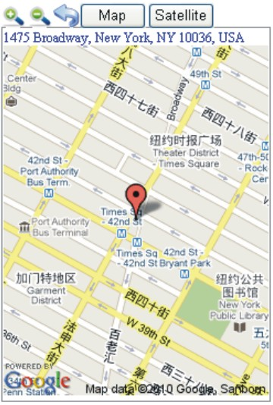

Send a SMS trigger website map link locate
Send SMS “LINKLOCATE*123456” to the tracker, “LINKLOCATE” is a command, “123456” is password; the tracker will locate immediately and send back the location information (map website internet link) of current location to the caller. use mobile phone to click the website link to visit the internet, and the location will display on the map on your phone(the mobile phone SIM card needs to have the GPRS function), if the command or password is not right, the operation is fault, the tracker will send back information “Bad Command ” or “Wrong Password. Please note your mobile phone must have a internet browser in order to go to the map link.
Set Object Move Alarm (Can be used as a car alarm):
Send SMS “SETMOVE*123456” to tracker, “SETMOVE” is a command, “123456” is password, the tracker will send back the information “SETMOVE OK” or “SETMOVE FAIL” to indicate the operation if it has success or failed。
After set the object move alarm, the system will monitor the object continuously, if the object is moving, the tracker will send alarm and location information by SMS to who enable the alarm, and every 5 minutes the tracker will send alarm information by SMS until the tracker stop moving.
The object move alarm SMS is as follow:
ObjectMove
Latitude:22.680206N
Longitude:114.146998E
Speed(km/h):45.0
Direction(Degrees):303.30
GMT:2008/04/25 08:29:06.000
Battery:78%
Over Area Alarm:
Send “SETAREA*123456*A22.670000N114.140000E*B22.680000N114.150000E” SMS to the tracker, “SETAREA” is a command, “123456” is password, “A22.670000N114.140000E” is the longitude and latitude of the first point(Point A) location, “B22.680000N114.150000E” is the longitude and latitude of the second point(Point B) location.
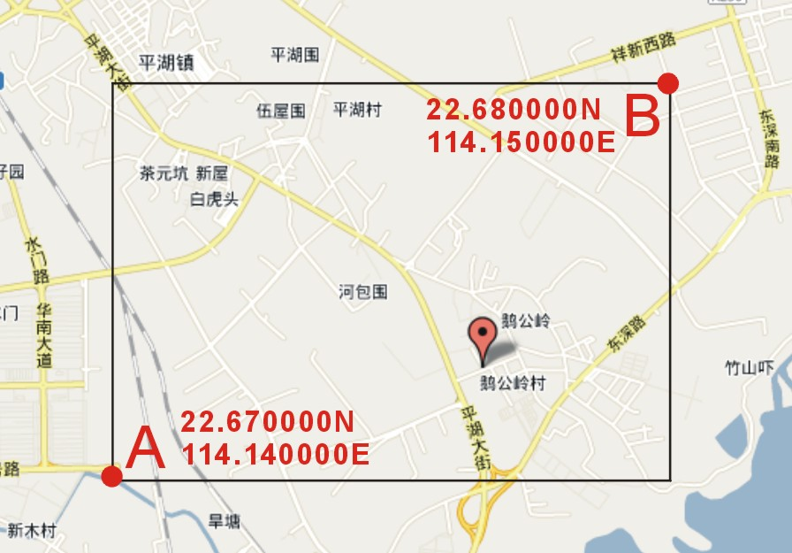

Note: the over area set needs 2 points, it is A and B, Point A must be on the bottom left of point B, the format of latitude and longitude of every point is as follows: Latitude format is YY.YYYYYYN, it has 8 digits, the last is N or S, means north latitude or south latitude, if the digit is not reach to 8 please add zero to 8 digits, Longitude format is XXX.XXXXXXE; it has 9 digits, the last is E or W, means east longitude or west longitude, if the digit is not reach to 9 please add zero to 9 digits, if the command and password is right, the tracker will send back the information “AREASET OK” or “AREASET FAIL” to indicate the operation is success or failed.
After set the over area alarm, the system will locate every 5 minutes and check the object is in the preset area or not, if the object is go out the area, then the tracker will send SMS to the phone who enable the alarm.
The over area alarm SMS information is as follow:
Over Area
Latitude:22.680206N
Longitude:114.146998E
Speed(km/h):45.0
Direction(Degrees):303.30
GMT:2008/04/25 08:29:06.000
Battery:89%
Over Speed Alarm:
Send SMS “SETSPEED*123456*040” to tracker, “SETSPEED” is a command, “123456” is password, “040” is the preset report speed, the speed must be 3 digits , from 000 to 999, unit is Km/hour, the tracker will send back the information “SETSPEED OK” or “SETSPEED FAIL” to indicate the operation is success or failed。
After setting the over speed alarm, the system will locate every 5 minutes and check the speed of the tracker is higher than the preset speed or not, if the speed is higher than the preset speed, the tracker will send SMS to the phone who enable the alarm.
The over speed alarm SMS is as follow:
Over Speed
Latitude:22.680206N
Longitude:114.146998E
Speed(km/h):45.0
Direction(Degrees):303.30
GMT:2008/04/25 08:29:06.000
Battery:78%
Set Real Tracking Mode:
Send SMS “SETTRACKING *123456*15M030T” to tracker, “SETTRACKING” is a command, “123456” is password, “15” is locate interval time, “M” means the time unit is minutes, interval time is from 00 to 99, must be 2 digits, “030” is the preset total tracking times, “T” means times, the tracking time is from 000 to 255, must be 3 digits, “15M030T” means every 15 minutes locate one time, total 30 times.
After setting the real tracking mode, the tracker will locate the object once every preset interval time and send SMS to preset phone with the location information, when it reaches to the max locate times it will cancel the tracking mode automatically.
Cancel the real tracking mode: Send SMS “CANCELTRACKING*123456” to tracker, “CANCELTRACKING” is a command, “123456” is password, the tracker will send back the information “TRACK CANCEL”or “TRACK NOT SET” to indicate the operation is success or failed.
Note: if you set the over area report and over speed report and tracking mode at the same time, then the information SMS only send to the last one preset phone.
Cancel All Alarm Setting
Cancel all the alarm setting: Send SMS “CANCEALARM*123456” to tracker, “CANCELALARM” is a command, “123456” is password, the tracker will send back information “All Alarm Cancel”, and cancel all the alarm settings in the tracker, including shock alarm, over area alarm, over speed alarm, real tracking mode etc. if the command or password is not right, the operation is at fault, the tracker will send back information “Bad Command ” or “Wrong Password”.
Low Battery Alarm
When the tracker’s battery voltage is low, the GREEN LED on tracker will flash 3 or 4 times, and then the tracker will automatically send battery low information to the first preset phone number.
Monitor & Listen Sound around tracker
Send SMS “MONITOR*123456” to tracker, “MONITOR” is a command, “123456” is password, the tracker will call the user who send this SMS, after the phone is connected, user can listen to the sound around the tracker, the distance of the sound is about 3-10 metres.
Talking to Preset Phone:
Press button “B” or “C” on the tracker, the tracker will call the preset phone number B or C that you have set, after the phone is connected, tracker can talk to the preset phone, the tracker speaker should be closer to your ear so that you can hear clearly.
Set Power Saving mode (Set GPS On/Off Interval)
Send SMS “SETPOWER*123456*10” to tracker, “SETPOWER” is a command; “123456” is password; “10” is interval time, it means every 10 minutes the GPS will turn on and receive the location one time, the interval digit must be a 2 number, from 00 to 99, Unit is minute, if the time is longer then the power saving is longer, 00 means GPS normally ON, and 99 means GPS normally OFF, (The factory default is 99, means GPS normally OFF, when phone to the tracker to trigger the locating, GPS turn on. If the real tracking mode is set, the GPS will normally ON).
“SOS”
Press the “SOS” button for 6 seconds, first the LED will flash fast, then the LED will turn OFF, release the button, the tracker will send help information to all the 3 preset phone.
HELP！
Latitude:22.680206N
Longitude:114.146998E
Speed(km/h):45.0
Direction(Degrees):303.30
GMT:2008/04/25 08:29:06.000
Battery:68%
If the user receive the HELP information, please note that the help button must be pressed.
Installation Guide
The antenna of the GSM and GPS is inbuilt into the tracker, please note that the install location of the tracker must be able to receive the GPS signal.
The tracker has a built in high capacity Li-Ion battery, on standby mode it can last up to 3 days. Also you can connect the tracker to a 12V car battery, this can keep the tracker’s power on continuously.
Notes
The GPS needs 10-200 seconds to locate the position, when the GSM signal is weak or the network is very busy, the SMS may be delayed in sending by the GSM network, this is normal.
Metal objects can reduce the signal of GPS and GSM, please keep away from the magnetic components.
Trouble Shooting
  - Auto power off: please confirm the tracker battery can be used, try to recharge it; and the SIM card has been installed properly.
  - If the tracker can not send back information by SMS, please confirm the SIM card has caller ID display and SMS service function, and the SIM card PIN code should be disabled.
  - The tracker has no response, and no ring, please confirm the tracker has been powered on and the SIM card has enough charge, and the mobile phone’s reception is strong enough.
Instruction List
Function | SMS Information | Note | Reply | Note
Add phone number | ADDPHONE*123456*A*13322990998 | Any mobile phone can set | ADDPHONE OK | Reply to the operation phone
Delete phone number | DELETEPHONE*123456*A | Any mobile phone can delete | DELETEPHONE OK | Reply to the operation phone
Check phone number | CHECKPHONE*123456 | Any mobile phone can check | CHECKPHONE A：13322990998；B：13322990033；C：13316868198； | Reply to the operation phone
Change password | CHANGEPASSWORD*123456*888888 | Only preset phone can change | New Password：888888 | Reply to operation phone that been preset
Check password | CHECKPASSWORD | Only preset phone can check | The Password: 888888 | Reply to operation phone that been preset
Set langue to English | ENGLISH*123456 | Any mobile phone can set | Set langue to English | Reply to operation phone
Set langue to chinese | 设置中文*123456 | Any mobile phone can set | 设置中文成功 | Reply to operation phone
Calling trigger SMS mode report location | SMSMODE*123456 | Any mobile phone can set | Set Report Mode to SMS | Reply to operation phone
Send SMS trigger SMS report location | SMSLOCATE*123456 | Any mobile phone can set | latitude & longitude speed direction time battery | Reply to operation phone
Calling trigger Map link mode report location | LINKMODE*123456 | Any mobile phone can set | Set Report Mode to Map Website Link | Reply to operation phone
Send SMS trigger map link report location | LINKLOCATE*123456 | Any mobile phone can set | Current location map website link | Reply to operation phone
Set object move alarm | SETMOVE*123456 | Any mobile phone can set | SETMOVE OK  The alarm will be:  ObjectMove + location information | Reply to operation phone
Set over area alarm | SETAREA*123456*A22.670000N114.140000E*B22.680000N114.140000E | Any mobile phone can set | SET AREA OK  The alarm will be:  OverArea  + location information | Point A must be at the east bottom of point B
Set over speed alarm | SETSPEED*123456*080 | Any mobile phone can set | SETSPEED OK  The alarm will be:  OverSpeed + location information | Reply to operation phone
Set tracking mode | SETTRACKING*123456*xxMyyyT | Any mobile phone can set | SETTRACKING OK | xx is 0 to 99, unit is minutes, yyy is 001 to 255, every xx minutes locate once, total yyy times.
Cancel all alarm setting | CANCELALARM*123456 | Any mobile phone can set | ALARM CANCEL or ALARM NOT SET | Reply to operation phone
Monitor & Listen sound | MONITOR*123456 | Any mobile phone can set | Call the user and monitor sound around the tracker | Reply to operation phone
Talking to Preset Phone | Press Button B or C |  | Call and talk to the preset phone B or C | Call the preset phone
Set power saving mode | SETPOWER*123456*xx | Any mobile phone can set | Set Power Saving OK | xx is 00 to 99, unit is minutes, 00 is normally ON, 99 is normally OFF (Default is 99)
SOS | Press SOS button until the LED TURN OFF |  | Send HELP information to all preset phone by SMS | Send information to preset phone
Notes
  - Please add preset phone first then change the password.
  - SMS information:, “*” is the star key, “” is not including in the SMS information, it is just used to indicate the information.
Specifications
GSM Frequency | 850/900/1800/1900 MHz | GPS channel | 32 channels
GSM / GPS Antenna | Built in | Standby Current | 2-5 mA
Locate precision | 10-20 Metres | Recharging Current | 5V/300mA
GPS working Current | <50mA | GPS Cold Start Time | 36 seconds
Working Temperature | -20 ⁰C to +55 ⁰C | GPS Hot Start Time | 1 second
Storage Temperature | -40 ⁰C to +80 ⁰C | Absolute Temperature | -35 ⁰C to +70 ⁰C
Battery | Li-ion 800mAh (BP-6M)

