LA-9011 GSM/GPS Tracker
User Manual

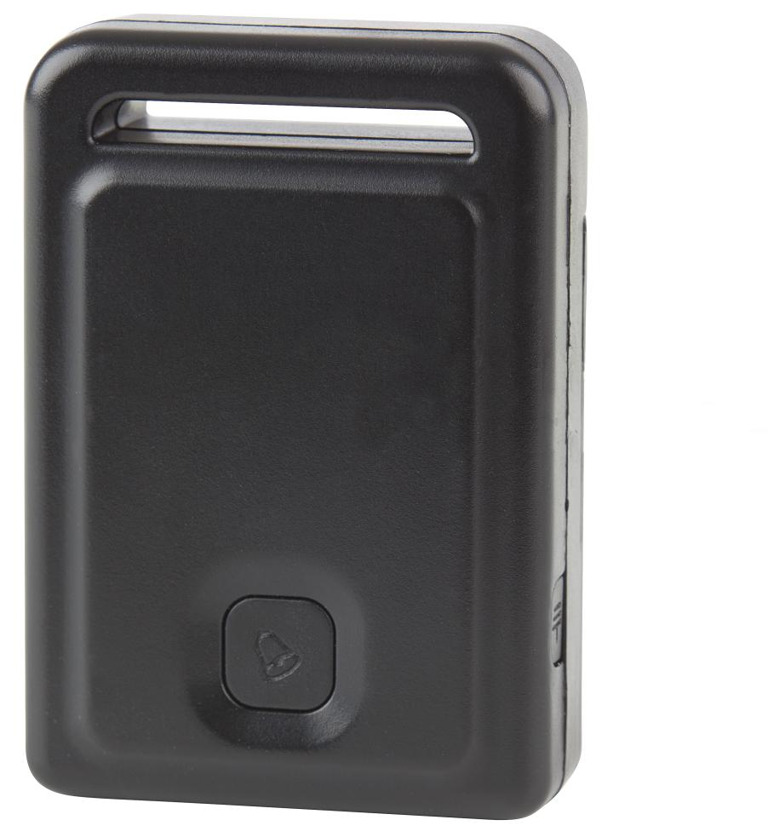

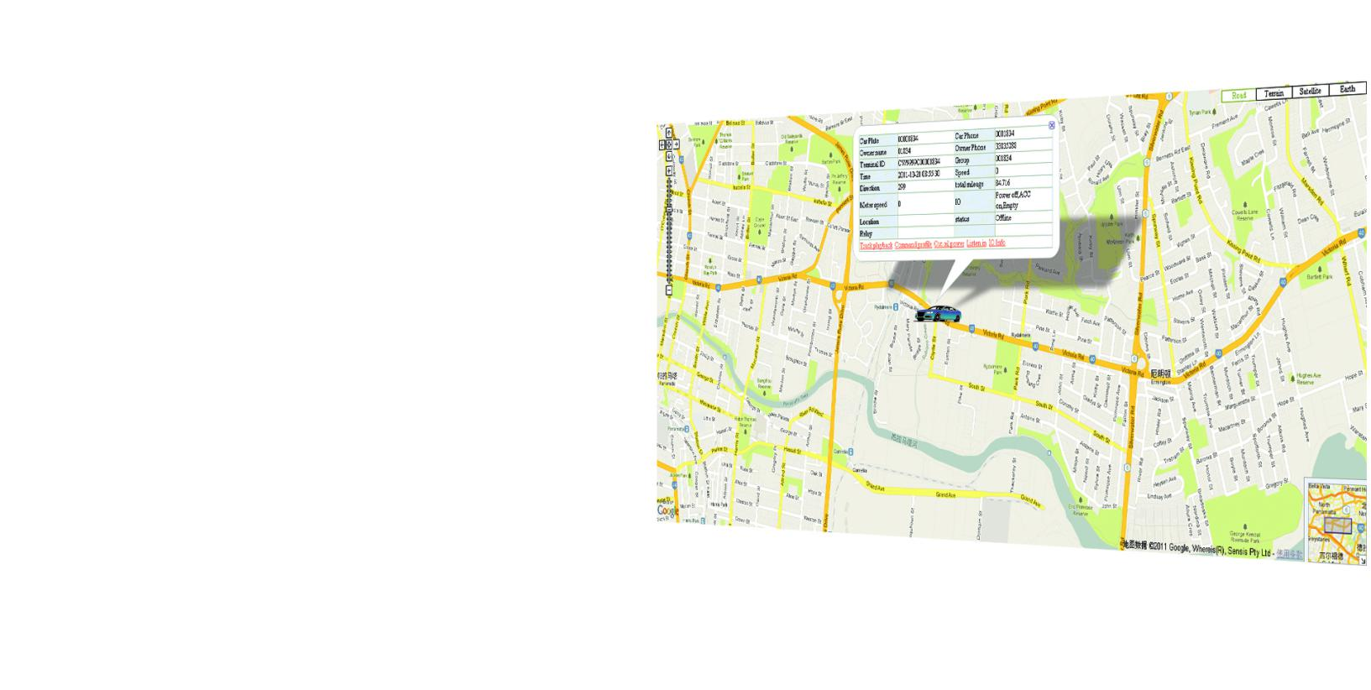

GSM/GPS Tracker

A GSM and GPS Tracking solution to locate and track the whereabouts of your vehicle in real time via the Internet on a computer or Smart phone. The device is easy to install with only 2 - 4 wires to connect. Insert a GSM SIM card (not included) and hide the device away on a metal surface or carpet using the included Velcro adhesive. It works by sending the vehicle's GPS coordinates via the GSM network to the free online tracking service, which shows the location on Google Maps. It can also SMS longitude and latitude coordinates to up to 3 mobile phones, as well as alerts when vehicle exits a pre-determined area or exceeds pre-set speed.

Other features include an engine kill function to remotely disable the petrol pump, and movement sensor to extend battery life. An SOS/Panic button is also supplied which can send an SMS to the pre-programmed mobile phones. The built-in rechargeable Li-ion battery will keep the device functioning for up to 4 days when power is disconnected, which could help you locate the vehicle should it have been stolen and abandoned.

There is no installation or on-going tracking charges. You only pay for the GSM SIM card and service.

INDEX
- Contents
- Before Use
- How to Use
- Platform Operation Guide
- Instruction Description
- Instruction List
- Notes
- Trouble Shooting
- Specifications

Contents
Before Use
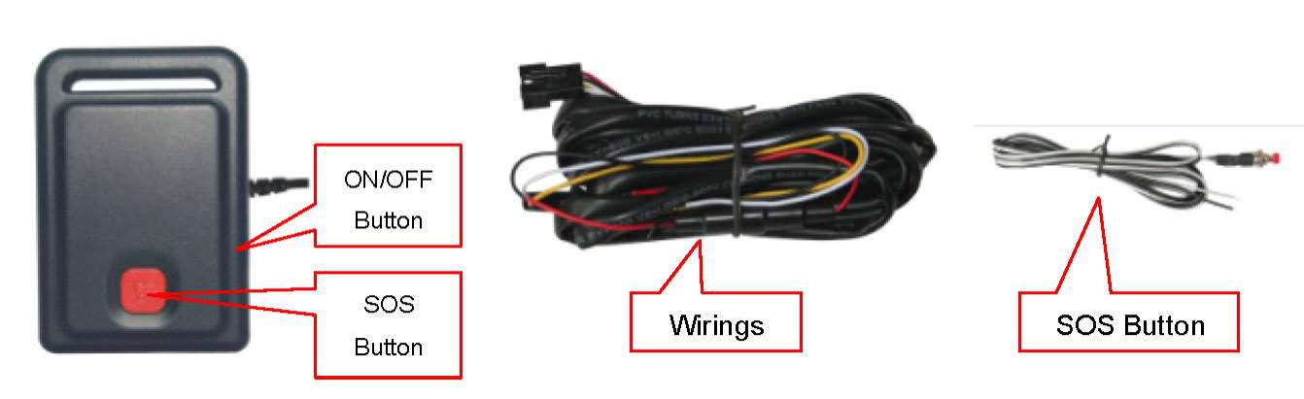
1. Installing The SIM Card
Remove the battery cover according to the following diagram below. Remove the battery exposing the SIM card socket. Push the SIM card metal cover up to release the socket and place the SIM card into the socket (ensure that the SIM card contact is facing down). Cover the SIM card metal cover and push to the “LOCK” position to lock the SIM card, and then put the battery in and lock the battery cover.
Note: 1. The tracker uses a 2G GSM network, it uploads tracking only through GPRS. It can not work on a CDMA or 3G (WCDMA or CDMA2000) network. (Some 3G SIM cards can be used on a 2G GSM network, this SIM card can be used in this tracker)
2. Please confirm the PIN code of the SIM card is disabled.
3. Before installing or uninstalling the SIM card, please power off the tracker
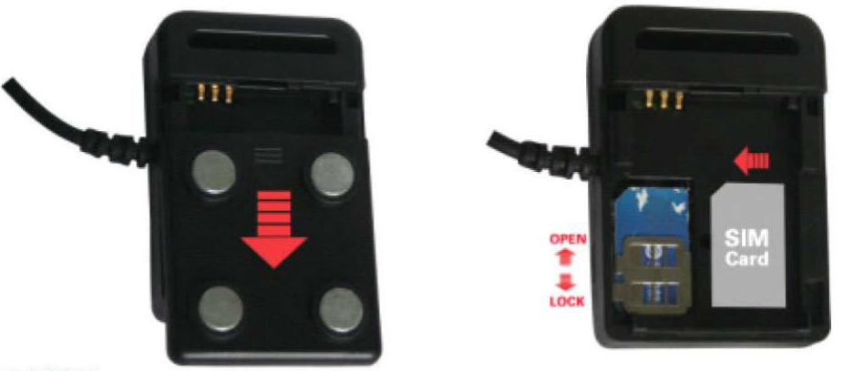
2. Power ON/OFF
- When power is OFF, please press the “ON/OFF” button until the GREEN LED turns ON.
- When power is OFF, connect the power to12V or24V source, the tracker will power on automatically.
When the power is ON, press and hold the “ON/OFF” button until the GREEN LED flashes to turn the tracker OFF.
When the battery voltage in the tracker is too low, the tracker will power off automatically.
3. LED Flash Indicator
GREEN LED Flashes once :GSM & GPS work correctly
GREEN LED Flashes twice :GSM working correctly, no GPS signal
GREEN LED Flashes three times :GSM & GPS working correctly, battery is low
GREEN LED Flashes four times :GSM working correctly, battery is low and no GPS signal
GREEN LED ON continuously :GSM searching networks
GREEN LED OFF continuously :Power off
GREEN LED Flashes fast :Incoming call or sending an SMS
RED LED Flashes once :Uploading current tracking
RED LED Flashes twice :Can not upload tracking now
4. Recharging & Power Supply
Warning: this tracker is powered by 9-28VDC, high AC or DC voltage may damage the unit, so please check the power supply first before installation.
For use in a vehicle, it is necessary to connect the tracker to the car battery all of the time, after the back up battery is full, the built in recharging circuit will stop recharging. If the tracker is not moving, then the tracker will go into sleep mode to save power draining from the car battery.
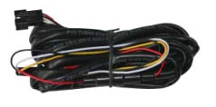
Wiring
RED----------12V/24Vcar battery
BLACK------GND (Car Body)
YELLOW----Cut Relay Driving (Immobilizer Control)
WHITE-------External SOS button
5. Restoring To Default (Factory Configuration)
Power off the tracker first, press the “ON/OFF” button and don’t release (remove the battery and place it in the tracker or connect the power wire to the car battery) to power automatically. A few seconds later the GREEN LED will flash 10 times and turn ON continuously, Then release the “ON/OFF” button. The tracker is now set to default configuration.
Notes: After default has been set, all IP / APN / GPRS / TIME ZONE settings are reverted back to default, all preset phone numbers are deleted and the password is changed to 123456. All the alarm settings are cancelled, if the IP/APN/GPRS name& password/TIMEZONE are changed. You need to set these again by sending an SMS.
6. Antenna
The Antenna of GSM and GPS are built in to the tracker.
Please position the tracker away from metals, as this may reduce the GSM and GPS signal.
7. Shock Sensor Control GPS ON/OFF & Power Saving
This tracker has a built in shock sensor, default is SHOCKCONTROL mode. When the tracker begins to move the tracker will turn on GPS and upload the location automatically, when the tracker stops moving 2 minutes, the tracker will turn off GPS & GPRS automatically (Stop uploading location).
8. Working Conditions
The working temperature is -20 0C to 60 0C, over this range the tracker may not function correctly.
How To Use

Firstly purchase a 2G GSM phone SIM card, which needs SMS service and incoming caller ID display and GPRS function. Please disable the PIN code of the SIM card, the SIM card phone number is the tracker number and all the operations (calling and sending SMS) to the tracker has the same number.
After installing the SIM card in to the tracker, power on the tracker. Send an SMS to the tracker for setting the APN name and GPRS username & password first, but for some mobile service providers it is not necessary to set an APN or GPRS user name & password, please call your mobile service provider to confirm these.
Please confirm the tracker can receive the GPS signal and GSM signal (you should be outdoors to get GPS signal, the green LED will flash once every 4 seconds meaning the GSM and GPS are receiving signal). When the tracker begins to move, the tracker will upload the location to the website (Default IP is 113.106.89.149, 9066 , you should set the IP first if the IP is changed. A notice will display on the website if IP is changed).
The Real Time Tracking Platform: www.999gps.com .
Platform username and password is the last 6 digit number of the tracker’s ID number, the label on the back of the device has the S/N number. This number is the ID number, also user can send an SMS “ID*password” (Tracker default password is 123456) to the tracker to check the ID number. The user can change the password and user information (Such as the car number plate and phone number), You can not change the username, login to the website to see the current location on Google maps, also user can display the history tracking in the specified date and time.

Platform Operation Guide

Every tracker has a unique user name and password, the user name is the last 6 digit number of the tracker. For example the tracker ID is:CW0810C12345678901 then the user name on the platform of the tracker is : 678901. The platform password for this user name also is :678901. Please send an SMS “ID*123456” to tracker to check the tracker ID.
The user can change the password and user information (Such as a car number plate, or phone number), but you can not change the user name.

Platform Login:
Visit the website www.999gps.com , select the language version and the login page will display as follows:
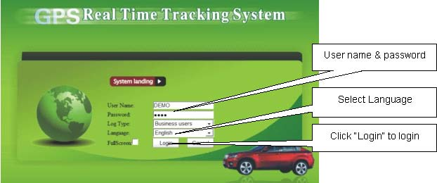
Change User Information:
Click the menu “Other” on the top of the page, there will be a pull-down menu. Click the “User Info” button, there will be a menu as follows:
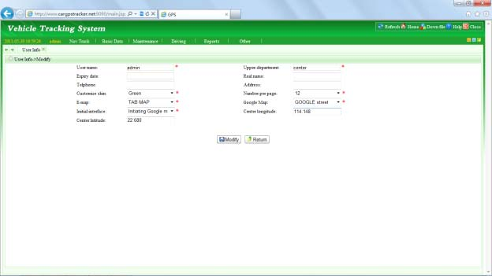
The “user name” and “upper department” can not be changed. The Expire date, Telephone, Number per page, real name and address is not necessary to change. The “customized Skis” you can change to Green, Blue or Orange. If you need to use local maps, you need to select E-map which is “TAB MAP”, otherwise it is not necessary to change. Google Map is “GOOGLRE map” please do not change this selection, otherwise the map will not display correctly. The Initial Interface is “initial Google map” please do not change this selection, otherwise the map will not display correctly. Centre Longitude and centre latitude is the map center location when you login, you can input the longitude and latitude of your local centre location. Then every time you login it will display the map of your local location.
Changing The Car Number Plate Display And Phone Number:
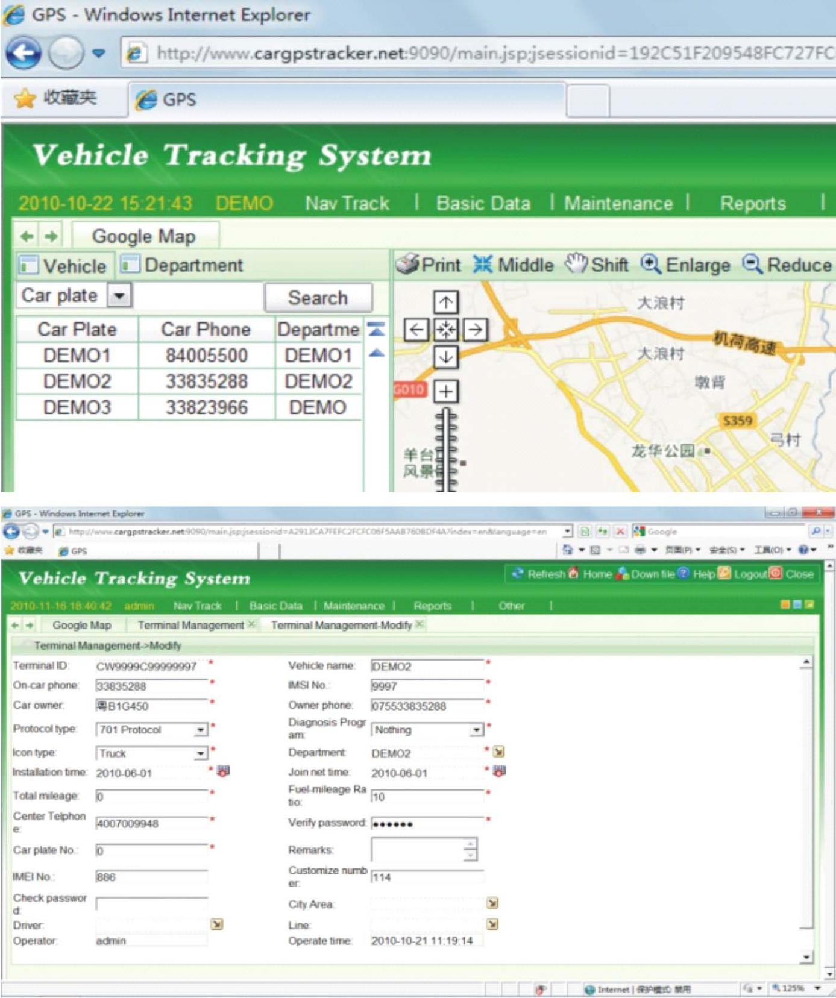
After logging in to the platform, the upper left window will display the number plate. Please see the first picture, you can change the car number plate and car phone number that displays in the upper left window. You cannot change the department that displays in the upper left window, Click the menu “Basic Data” on the top menu, there will be a pull-down menu, click the “Terminal Management”, there will be a menu as the above second picture.

The “Terminal ID” and “Department” can not be changed; the “Vehicle name” is the name displayed on the table of the “Car number plate” in the upper left window. It is also the name of the www.999gps.mobi login name. The “On-car phone” is the phone display on the table of the “Car phone” in the upper left window; the “car owner” is the owner display on the table of the “Owner name” in the down right window; the “owner phone” is the owner’s phone number and this phone will not be displayed on the screen. It is used as a service center to contact the car owner; the “Protocol type” is “701 Protocol”, (Please don’t change this selection). The “Icon type” is the tracker icon display on the map window, you can select “Car, Bus, Truck” etc; The others is not necessary to change.

Changing The User password:

Click on the menu “Other” on the top of the page, there will be a pull-down menu. Click the “Modify Password”, option, there will be another menu. Inputting the old password and new password is ok. The user name can not be changed by the user.

Platform Tracking Page:

After logging in to the platform, the latest location of all the tracker will display on the map. Every 2 minutes the display will update the new location of all the tracker, if the tracker is moving then the icon of the tracker is GREEN. If the tracker has stopped moving then the icon of the tracker is BLUE, if the tracker is alarming, then icon of the tracker is RED. The icon type (Car, truck, bus etc.) of the tracker you can change in the “Terminal management”. This page can be used if there is more than one tracker.
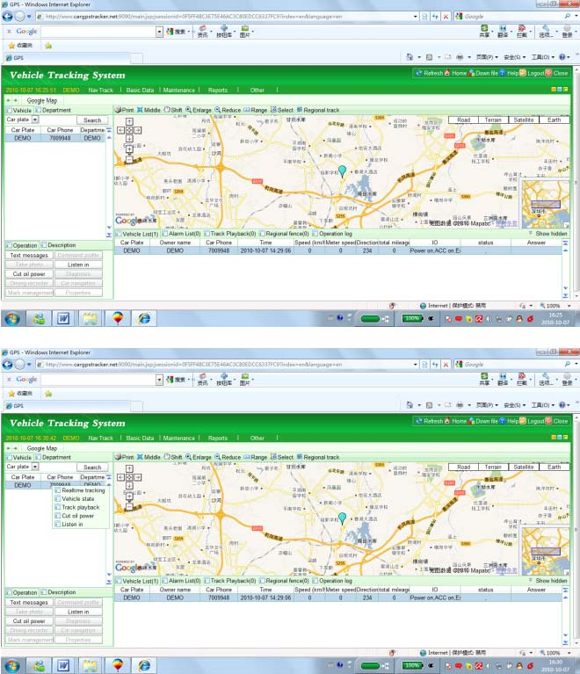
Click the left button of the mouse once on any car number plate display in the upper left window, the latest location of the car will display on the map. This can be used to check the latest car location, also the latest status of the tracker will display below “Vehicle list” in the bottom right window, click the right button of the mouse once on any car number plate in the upper left window. There will be a pop up menu, and then move the mouse and click the left button of the mouse to operate the instructions, such as “real time tracking”, “vehicle state, “tracking playback” etc.

Display Tracking History:
Move the mouse over the car number plate, click the right mouse button to display a pop up a menu. Click the “Track playback” button, there will be a menu to let you select the date and time (Please note the time period can not be longer than 24hours).
Select date and time, then click “Confirm”, the tracking will be loaded on to the computer.
Click “OK”, click the “Track playback” menu with. There will be another track display back menu, click the “Play” menu with left button, the tracking will begin to display on the map.

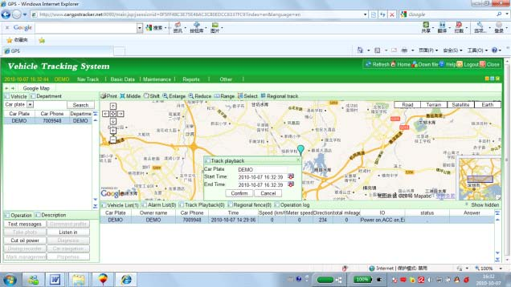

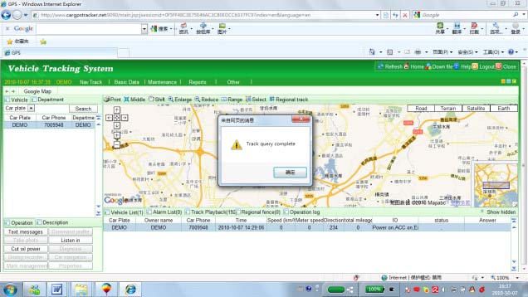

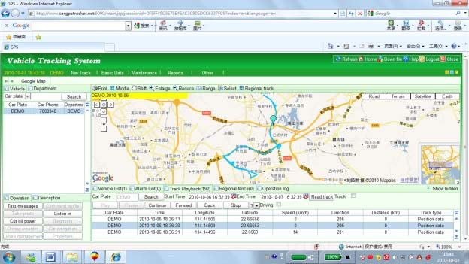

Real Time Tracking :
Click the right mouse button to display a pop up a menu, then click the “Real time tracking” button. This will track the selected car in real time. And the information will be updated every 30 seconds.

Over Area Alarm (Geo-Fence Alarm):
This function is set on the platform, after logging in to the website. Click the “Regional fence” menu in the bottom right window, search and select your car first and click the “Add fence” menu to add a fence to the tracker. First select a tracker first and then use the left button of the mouse to define the area and right button of the mouse to end the definition.
You can select in or out of an area alarm, the alarm information will display on the alarm list. Click the menu of “Remove Fence” or “Clear Fence” which will cancel the over area alarm.
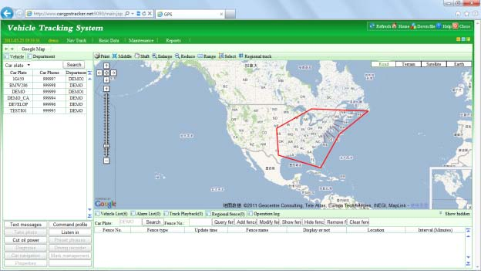
 Over Speed Alarm:

This function is set on the platform, after logging in to the website. Click the “Command profile” menu in the bottom left window. A menu will pop up, search and select your car first then enable the “Set over speed alarm” menu. You can define the speed of the over speed alarm, stop alarm etc, After defining the speed alarm, the alarm information will display on the alarm list. You can check and output the alarm list.
Click the menu of the “set over speed alarm” to make the selection disabled.

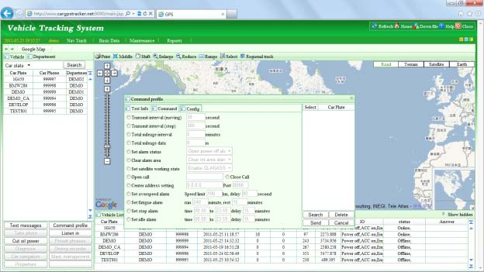

 Listening To The Microphone

Login in to the platform, click the “Listen in” menu in the bottom left window. A menu will pop up,
search and select your car first, and then input the number of telephone that you will use. The “License
Password” is the “verify Password” defined in the “Terminal Management” menu and click “Send”. The instructions will be sent to the tracker by the platform, then the tracker will call the number that you just input in. When the phone rings, pick up the call, then you can listen to the microphone in the tracker. The
driver will not know you are listening.

Also you can Send SMS “MONITOR *123456” to the tracker to listen from the microphone around the tracker,
“MONITOR” is a command, “123456” is password. The tracker will call back, pick up the call and listen in.
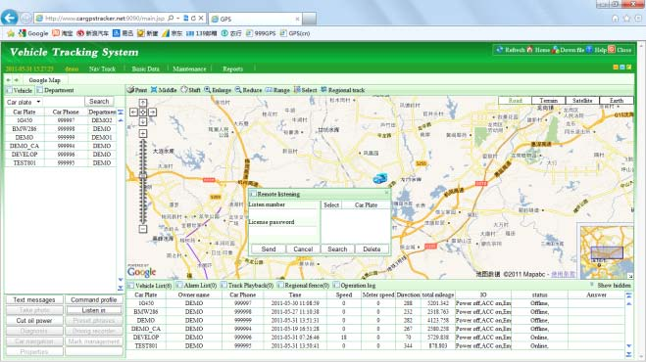

Cut Oil Power (Remote Turn Off Car Engine)

Login in to the platform, click the “Cut oil power” menu in the bottom left window. A menu will pop up,
search and select your car first, enable the “close circuit” or “Close Oil Supply”, and input the “Verify
Password” defined in the “Terminal Management” menu and click send.
The instructions will be sent to the tracker by the platform, and this will cut the relay connection and the car engine will be turned off. The same operation, click the “Cut oil power” menu in the bottom left window.

A menu will pop up, enable the “open circuit” or “open Oil Supply” and input the “Verify Password” defined in the “terminal Management” menu, and click “Send”. The instructions will be sent to the tracker by the platform, and this will make the cut relay back to the connection state, and then the car engine will be turned on.

Also you can Send SMS “STOPENGINE*123456” to tracker, “STOPENGINE” is a command, “123456” is password, the car engine will be turned off immediately. The tracker will send back the information “Car Engine turn off” if the password is not right, the tracker will send back information “Wrong Password”.

Note: Turning off the engine is very dangerous when the car is moving, this will make the car difficult to control and maybe cause an accident. It is recommended to connect the relay cut the start motor wire, ensure the car’s engine can not be started again.

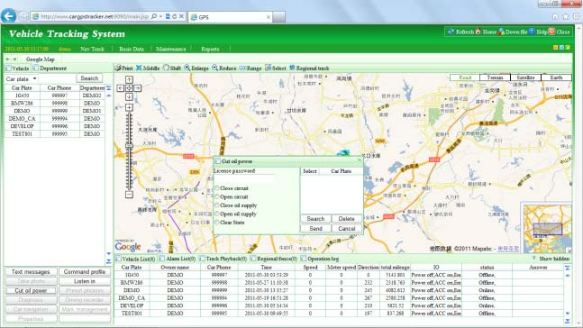

A relay is needed to be installed in order to turn off the car engine, also a diode is necessary to protect the tracker driving wire.

The diagram is as follows:
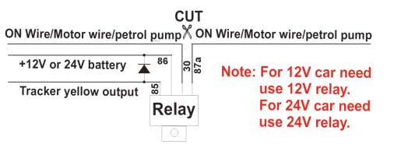
InstructionDescription

The tracker ID is printed on the label of the tracker, the S/N number on the label is also the ID number. If the label is missing, send an SMS “ID*123456” to tracker, in which, “ID” is the fixed command and “123456”is the password. Having successfully been made, there will be a SMS “ID: CW0800C12345678901”, in which, “CW0800C12345678901” is the ID and every tracker corresponds to the only number. This number is used to differentiate the tracking uploaded to the website from others.

The last 6 digit number of the tracker ID is the user name and password of the tracker on the platform, for example the tracker ID is : CW0800C12345678901, and then the user name on the platform of this tracker is : 67890. The platform password for this user name also is 678901, the user can then login to the platform for changing the password.

Setting The Time Zone:

The data & time of the tracker uploaded to the website is GMT time (add or minus a fixed digit is your local time), you can send a SMS to the tracker to change your upload time from GMT to your local time automatically. Send SMS “TIMEZONE*123456*XXX” to the tracker, in which, “TIMEZONE” is the fixed command, “123456” is the password and XXX is the time zone of your local time. It is from -12 to +12, for example: New York is -05, Paris is +01. Having successfully been set, there will be a SMS “TIME ZONE XXX”.
Note: please confirm your local time zone, and if the time zone is not set, the tracker will upload tracking with GMT time.

Set Website Server IP:

Send SMS “IP*123456*113.106.89.149,9066” to the tracker, in which, “IP” is the fixed command, “123456” is the password and “113.106.89.149,9066” is the IP address of the server computer of our website. Having successfully been set, there will be a SMS “IP:113.106.89.149,9066”. However, the IP address may be changed with the upgrade of our service which will be mentioned on the website.
Note: The tracker has a default IP address is: “113.106.89.149,9066”. It is not necessary to set again, unless our IP address has been changed or your setting has been changed, If the IP is changed, it will be displayed on the website.

Set APN name:

For some mobile service providers, the APN name must be set to get through the internet by GPRS. Send SMS “APN*123456*apn name” to the tracker, in which, “APN” is the fixed command. “123456” is the password and “apn name” is the APN name of a mobile service provider. Having successfully been made, there will be a SMS “APN: apnname”.
Note: Some mobile service providers it is not necessary to set a APN or GPRS username & password, please contact your mobile service provider to confirm this.

Set GPRS User Name & Password:

Send SMS “USERNAME*123456*username *password” to the tracker, “USERNAME” is a command, “123456” is the password of the tracker; “username” is the mobile service provider’s GPRS user name. “password” is the mobile company GPRS password, if the operation is successful then the tracker will send back the information.

“Username: username, Password: password”, please call the mobile service provider to get the GPRS username and password, some mobile service providers do not need the GPRS username and password. If the password is not right then the tracker will send back information “Wrong Password”
Note: Before uploading the tracking, the user needs to set IP, APN, GPRS user name & password (2G GSM network APN, GPRS name & password). This only needs to be set once, this will be then saved in the tracker. But if the tracker is set back to default, then these setting need be set again.

Add/ Delete /Check preset number:

The preset phone number is used to send alarm information by SMS, or use mobile phone to locate the tracker without platform. If the preset phone number is not set, then the alarm information can not send to the user by SMS (battery low, SOS, etc).

1. Add preset phone number by SMS

Send SMS“ADDPHONE*123456*A*number”(Not including the quotation marks “ ”, Number means the telephone number you want preset) to tracker is OK, “ADDPHONE” is a command; “123456” is password; “A” is preset number location, every tracker has 3 preset phone number locations, A and B, and C. So you can preset 3 phone numbers. If the add operation is successful, the tracker will send back the information ”Add Preset Phone OK”, if the password is not right, the tracker will send back information “Wrong Password”.

2. Delete preset phone number by SMS

Send SMS “DELETEPHONE*123456*A” to the tracker, “DELETEPHONE” is a command; “123456” is password; “A” is preset phone number location, there are 3 locations “A” and “B” and “C”; if the delete operation is successful, the tracker will send back the information ”Delete Preset Phone OK”, if the password is not right, the tracker will send back information “Wrong Password”.

3. Check preset phone number by SMS

Send SMS “CHECKPHONE*123456” to tracker, “CHECKPHONE” is a command; “123456” is
password; if the operation is successful, the tracker will send back the information “Preset Phone A:
13322990998； B：13316868198；C：13322990033. The phone number is just an example. If the password is not right, the tracker will send back information or “Wrong Password”.

Change /Check Password

1. Change tracker password
Send SMS “CHANGEPASSWORD*123456*888888” to tracker, “CHANGEPASSWORD” is a command; “123456” is old password; “888888” is new password; if the operation is success, the tracker will send the information “ New Password： 888888” to every preset phone number. If the password is not right, the tracker will send back information “Wrong Password”.
Note: Only preset phone can change the password.

2. Check tracker password
Send SMS “CHECKPASSWORD” to the tracker, “CHECKPASSWORD” is a command, if the operation is successful, the tracker will send back the information “Password：888888”; “888888”is an example.
Note: Only preset phone can check the password.

Locate the tracker by calling the tracker (Platform is not necessary):

1. Using the preset phone to call the tracker, after ringing 3 times, the tracker will hang up the call automatically and locate immediately, 10 seconds later, the tracker will send back the SMS location information (map web site link) of current location to the caller. User can use mobile phone to click the website link, and the location on map will display on the mobile phone(the phone SIM card need enable the GPRS function). If the tracker has not preset number, any phone call can trigger the tracker to locate immediately. If the tracker has preset number, then only preset phone call can trigger the tracker to locate immediately.
2. Basic Location information including Map Website Link, Battery etc. The SMS information sample is as follow:
http://www.followmegps.mobi/map.aspx?lat=40.756441&lng=-73.986378&l=en
Battery:91%
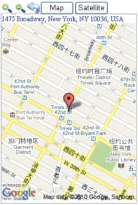
Send a SMS trigger locate by map link (Platform is not necessary)

Send SMS “LINKLOCATE*123456” to the tracker, “LINKLOCATE” is a command, “123456” is password; the tracker will locate immediately and send back the location information (map website internet link) of current location to the caller. Use smart phone to click the website link to visit internet, and the location will display on the map on your phone (the smart phone SIM card need enable the GPRS function), if the password is not right, the operation will not proceed and the tracker will send back information “Wrong Password.

Enable Shock & Move Alarm (Can be used as car alarm):

Send SMS “SHOCKALARM*123456” to tracker, “SHOCKALARM” is a command, “123456” is password, the tracker will send back the information “Set Shock Alarm OK” to indicate the operation is success, if the password is not right, the operation will not proceed and the tracker will send back information “Wrong Password” After enable shock alarm, the system will check shock sensor, if the shock sensor is trigger, the tracker will send alarm and location information by SMS to who set the alarm, and also send the alarm information to the website server, and later every 2 minutes the tracker will send alarm information by SMS if the tracker keep moving. 3 times alarm later, shock alarm will stop, user can send SMS to enable the shock alarm again, this function will not turn on GPS continuously, it will turn on GPS only when the shock alarm is trigger, so it will not reduce battery power. The shock& move alarm SMS is as follows: Shock Alarm
http://www.followmegps.mobi/map.aspx?lat=40.756441&lng=-73.986378&l=en
Battery:91%

Low Battery Alarm:

When the tracker battery voltage is low, the GREEN LED of the tracker will flash 3 or 4 times, and then the tracker will automatically send battery low information to the first preset phone number. the battery life can last about 1-2 days according the different using condition. (For example GPS and GSM signal is poor it will reduce the battery time, and keep moving and uploading will also make the battery time reduce to less 1 day.)

Cancel All Alarm Setting

Cancel all the alarm setting: Send SMS “CANCELALARM*123456” to tracker, “CANCELALARM” is a command, “123456” is password, the tracker will send back information “All Alarm Cancel”, and cancel all the shock alarm setting in the tracker. if the password is not right, the tracker will send back information “Wrong Password”.

Auto Re-power On and Reset Tracker

Auto power off and power on and Cancel all the alarm setting: Send SMS “RESET*123456” to tracker, “RESET” is a command, “123456” is password, The tracker will power off and then power on automatically, this will take a few minutes, and then cancel all the alarm setting in the tracker, including shock alarm, over area alarm, over speed alarm, keep online(change to shock control), stop working(change to start working), etc. the tracker will send back information “Reset Tracker”, if the password is not right, the tracker will send back information “Wrong Password”.

“SOS” Emergency

Press the “SOS” button for 6 seconds, the LED will flash quickly and then the LED will turn OFF. Release the button and the tracker will send SOS help information to all 3 preset phones. HELP ! ! ! http://www.followmegps.mobi/map.aspx?lat=40.756441&lng=-73.986378&l=en
Battery:91%

If the tracker receive the HELP information, please note that the SOS button must be pressed, please call the driver to confirm with the user is safe or not or call the police. The SOS function need installing the external SOS button, install the external SOS button in a hidden place that driver can press the button, connect one wire of the SOS button to GND (car body), another wire of the SOS button to tracker SOS wire,
Auto Re-power on & Resettracker | RESET*123456 | Any mobile phone can set | Tracker Re-power on and cancel all alarm setting | Reply to operation phone
SOS Emergency | Press SOS button until the GREEN LED turn off |  | HELP + location information | Send SOS HELP information to all preset phone

1.The default password is 123456, you can change the password.
2.All the SMS information is in English word,“*” is the star key, “” is not including in the SMS information, it is just used to indicate the information.

Notes:

Please confirm that the SIM card PIN code has been disabled (meaning if the SIM card is used on a mobile phone is not necessary to input any password). Otherwise the tracker can not find GSM network, the Green LED will stay ON .
This tracker use 2G GSM network, and it upload tracking only through 2G GPRS, it can not work in CDMA network or 3G (WCDMA or CDMA2000) network.
The antenna of GSM and GPS is built in to the tracker, please note that the install location of the tracker must can receive the GPS signal. Normally positioned at the back of the seat or arm rest box or under the back window. Please keep the tracker away from metals or magnetic components.
The tracker built in high capacity Li battery, recharge one time can use about 1-2 days (standby mode), also you can connect the tracker to the car battery all the time, this can keep the tracker has power supply continuously, and the charging circuit will control the recharging.
The GPS need 10-200 seconds to locate the position, when the GSM signal is weak or the network is very busy ,the SMS maybe delay to send by the GSM network, this is normal.
The tracking data on our server will be kept for 3-6 months, the old data will be deleted.

Trouble Shooting

The tracker auto power off: please confirm the tracker battery have enough power. Confirm the adapter is working well (When charging the LED on the adapter is RED, if the LED is GREEN means the charging is finished, the charging process will cost over3hours).
After powering on the tracker and the GREEN LED is on, if the tracker does not ring and respond please check that the SIM card has been installed properly, the SIM card PIN code is disable, and the SIM card has enough charge, and the mobile phone can work well in that place. If the tracker works well the Green LED will flash once every 4seconds.
If the tracker can not upload the location to the website, please confirm the SIM card has GPRS function, and has set the APN or GPRS username & password (call the mobile service provider to confirm it is necessary to set these or not). if the tracker does not move, the tracker will not upload tracking.
If the tracker can not send back information by SMS, please confirm the SIM card has ID caller display function and SMS service function. Please read the SMS information of the tracker and check the instruction& password is right or not.
When calling the tracker it continuously rings without hanging up, please check the tracker has set the preset phone number, use the preset phone or delete the preset phone number or set the tracker back to default.
Can not login the platform: use SMS to check the ID of the tracker.
if you are going in a under ground park, some tracking will be lost. The GSM and GPS module will take a few minutes to receive signal and re-locate, some tracking maybe lost, this is normal.

InstructionList

Function | SMS Instruction | Note | Reply | Note
Set Time Zone | TIMEZONE*12345 6*XXX | Any mobile phone can set | Time Zone is XXX | Reply to operation phone
Set IP address | IP*123456*113.10 6.89.149,9066 | Any mobile phone can set | IP: 113.106.89.149,9066 | Reply to operation phone
Set APN name | APN*123456*apnn ame | Any mobile phone can set | APN :apnname | Reply to operation phone
Set GPRS user name & password | USERNAME*1234 56*username*pas sword | Any mobile phone can set | Username:username, Password:password | Reply to operation phone
Check tracker ID Number | ID*123456 | Any mobile phone can set | ID:CW0810C12345678 901 | Reply to operation phone
Add phone number | ADDPHONE*1234 56*A*1332299003 3 | Any mobile phone can set | Add Preset Phone OK | Reply to the operation phone
Delete phone number | DELETEPHONE*1 23456*A | Any mobile phone can delete | Delete PresetPhone OK | Reply to the operation phone
Check preset phone number | CHECKPHONE*1 23456 | Any mobile phone can check | A:13316868198; B:13322990998; C:13322990033; | Reply to the operation phone
Change password | CHANGEPASSW ORD*123456*888 888 | Only preset phone can change | New Password：888888 | Reply to operation preset phone
Check password | CHECKPASSWO RD | Only preset phone can check | Password: 888888 | Reply to operation preset phone
Send SMS trigger map link report location | LINKLOCATE*123 456 | Any mobile phone can set | Current location map website link | Reply to operation phone
Listen & Monitor sound | MONITOR*12345 6 | Any mobile phone can set | Call backand pick up the calling can listen | Call backto operation phone
Set shock& move alarm | SHOCKALARM*1 23456 | Any mobile phone can set | Set Shock& Move Alarm OK | Reply to operation phone
Remote turn off car engine | STOPENGINE*12 3456 | Only preset phone can set | Car Engine Turn Off | Reply to operation phone
Cancel All Alarm Setting | CANCELALARM* 123456 | Any mobile phone can set | All Alarm Cancel | Reply to operation phone

Specification

GSM Module | SIMCOM 900 | GPS Module | Sirf-Star or MTK
GSM Frequency | 900/1800MHz or 4 Band | GPS channel | 32channels
GSM / GPS Antenna | Built in | Locate precision | 5-20Meters
GPS Cold Start Time | 36seconds | GPS Hot Start Time | 1 second
Recharging Current | < 5V/300mA | Standby Current | < 10 mA
Uploading Current | <200mA/ 5V | Battery | 800mAh
Working Temperature | -200C to +55 0C | Absolute Temperature | -350C to +70 0C
Storage Temperature | -400C to +80 0C

