CCTR-632 3G GPS Watch Tracker User Manual ---V1-201612
Welcome to use this mini 3G WCDMA GPS watch tracker. This product is with GPS, GSM/WCDMA & wifi module, that has many new and unique functions, such as super power saving technology, LBS & Wifi locate technology (without GPS signal), real time uploading current location to server (user can control working mode), check current location or playing back history tracking on website or mobile phone etc. It contains high capacity rechargeable polymer battery (600mAH), working time can reach 1-2 days (10 minutes upload interval), This GPS watch is mini size, and easy to use, it is suit for kids, old parents, pets and outdoor workers tracking.
This tracker also have LBS locating (mobile phone base station CELL ID) & public wifi locating function, if no GPS signal in some place, such as underground park, indoor room, or around high building with bad GPS signal, the tracker will locate with LBS or wifi (the LBS or wifi locating precision is about 50-500m in the city, and the GPS locating precision is about 10m).
Using app you can check the current location & history track max to 1 month, the geo-fence alarm and working mode & other setting can be set on app, user register on the app with the watch ID, user name can be defined by user, the default server is HongKong server, user can ask the distributor to move the watch to your local server (HongKong / Europe Africa / Asia Oceania / South America / North America). Visit the following website or scan the following QR code can download and install the app.

http://www.igps.info/gpswatch
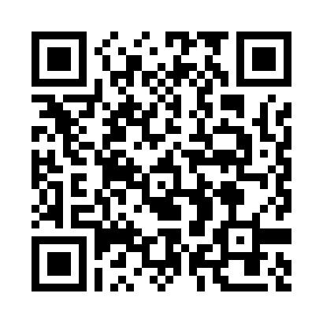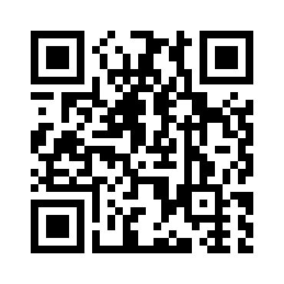
iPhone App Download & Install Android App Download & Install
Scan the following QR code or click the following link can download or read online the manual in Doc or Pdf format.
Word Version: http://www.igps.info/en/cctr-632-gpstracker-en-v1.doc
Pdf Version: http://www.igps.info/en/cctr-632-gpstracker-en-v1.pdf
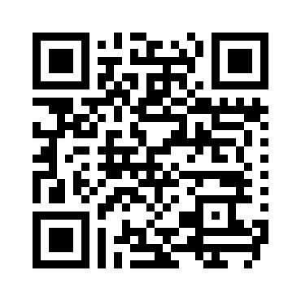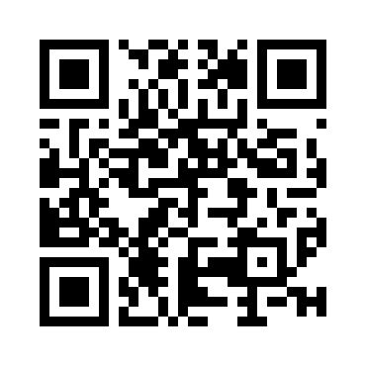
Manual Word Version QR Code Manual Pdf Version QR Code

Product:
CCTR-632 3G GPS Watch 1 set, Mini USB Charging Wire, Manual (CD or Print).
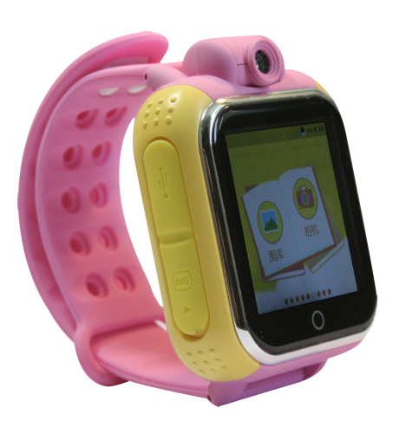
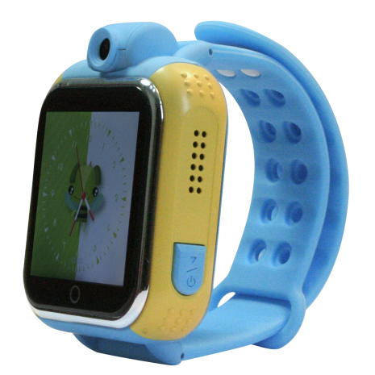
Charging
Camera

SIM Card
Speaker

Back
Talking
ON/OFF
SOS
Hang up

Function Specification:
- Frequency:2G GSM 850/1900 & 3G WCDMA 900/2100M, The other band can be ordered.
- GPS+LBS+Wifi 3 ways to locate.
- A GPS make the watch locate fast.
- 90 Degree Camera can take photo.
- Fashion Color 1.54 LCD with touch panel.
- Working time can reach 1-2 days with 600mAH battery.
- Listen / SOS / Geo-fence alarm.
- Make a call in Phone Book.
- Chat talking function.
- SOS alarm by calling & SMS.
- Watch timer alarm.
- Remove watch alarm.
- Health walking pedometer.
- History tracking data will keep 1 month on server.
- Auto configuration APN for GPRS.
- Low battery alarm by SMS.
- Life time free platform service charge.

Before Using:
1. Power On/Off
Power On: Press and hold the Button SOS over 3 seconds and then the LCD will display “HELLO”, then release the button ,and the GPS watch is powered ON.
Power Off: If the GPS watch is powered ON, press the SOS button one time, slide the screen to enter the “Setting” menu, then click “System” -- “Power off”, the watch will power off.
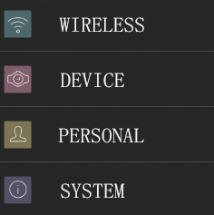
- SIM Card Installation(Micro card): This GPS watch need a micro SIM card (every month will cost about 10M-30M Byte data according the different working mode, order an data package can save money), Open the SIM card slot rubber cover with finger, push the SIM card in the slot by the following diagram direction, please note the direction of the metal contact pin and the bevel of the SIM card. After the SIM card is installed properly, you can hear a “Di Da” sound. Press the SIM card in the SIM card slot, the SIM card will come out a little, and then the SIM card can be pull out.
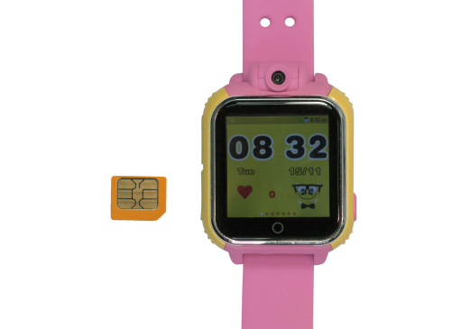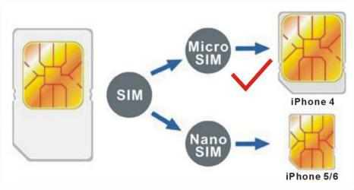
3. Low Battery Alarm
When the tracker battery voltage is low than 20%, the watch will send battery low information SMS to the authorized phone number. maybe a few hours later, the watch will turn off after the battery is gone out.
4. Recharging
This GPS watch uses the 5V DC voltage to recharge, connect the watch charging micro USB socket to the AC charger or PC USB, the GPS watch will begin to recharge, about 2-3 hours, the battery will be full, press once any button of the GPS watch tracker, the LCD will display the battery level.
5、GPS & GSM Antenna
The Antenna of GSM and GPS are built in the GPS watch.if can not locate please change a place to try again.
6、About Water-proof
This watch is not water-proof, but it can resist the water splash, but can not be in the raining or drop in the water.
7. Using Condition
The working temperature is -20℃ to 60℃, over this range the specification maybe can not reach the standard level. the storage temperature can reach to -40℃ to 80℃.

Simply Using Step
- First to buy a 2G GSM or 3G WCDMA mobile phone SIM card and enable data service, order a data package (Normally will use about 10M-30M byte data every month), install in the tracker, please refer the above Before Using 2.
- Press any SOS button till the watch power on, first time using please put the tracker outdoor for easy get GPS & GSM / WCDMA signal.
- Press SOS button once, the LCD will display, if the time change to GMT time, it means the GPS locate is normal.
- Using mobile phone to visit website : www.igps.info/gpswatch to download & install app, register the app user name (the default server is HongKong server), and then add the watch ID the device list.
- Clip the Map in the app to check the watch is online or not.
- Set the app setting by the following description,please refer APP Register & Operation.
- Send SMS “pw,123456,lz,x,y#” to tracker to set your local time and language, please refer Watch Operation & Setting.
- This tracker can auto download & configure APN & GPRS user name & password, if the auto configure is not right, the tracker can not upload location to server, please send SMS to tracker to change the APN & GPRS manually, send “pw,123456,ts#” to the tracker can check the current setting, call the tracker SIM card supplier to confirm the APN & GPRS is right, please refer Watch Operation & Setting.
- If the watch need change the server, please contact the dealer.
App Register and Operation
1. APP register
Before logging in, register the account first with watch ID, enter the 15 registration code(print on the back of the watch, also can be check in the watch menu) number and account name (Named by user), nick name , personal mobile phone, password, and then click “OK” to register, the registration code is unique and can not re-registered; reset password required registration code, login account and the registration phone number. the registration interface as shown below. If user have account before, it is not necessary to register again, user can add another watch to the old account.
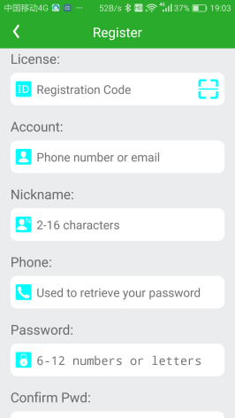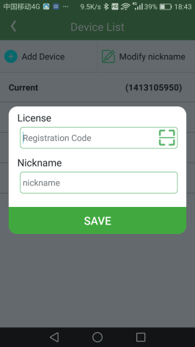
2. APP Log in
Please use the proper server: Default we use “HongKong” server, the other server please contact the dealer. before moving to new server, the administrator need add the watch ID to the new server first, if user select wrong server, the app can not control the watch or receive any information.
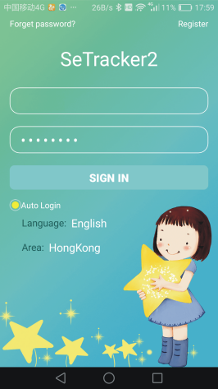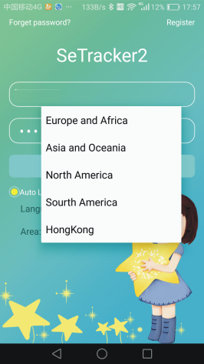
3. APP main menu & Function Description
After finish register, input the correcter account number and password, click login, enter the main menu. The main menu (Home Menu Display) show as below:
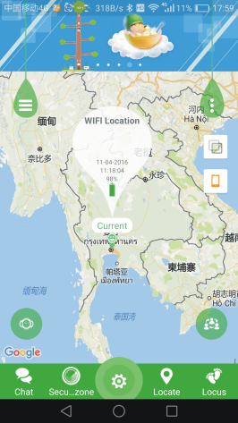
Function & Setting Description:
- Chat: Watch talk to mobile phone
App send voice to watch: After turn on record function. App start to record and sent to watch. The longest voice can be 15s. The watches into the chat interface short press to play the voice box.
Watch send voice to friend: Enter the wechat menu, select friend,hold to talk, release and then the vocie will sent to friend.
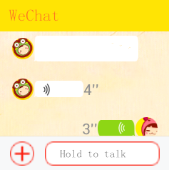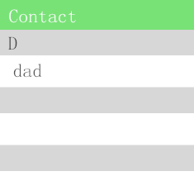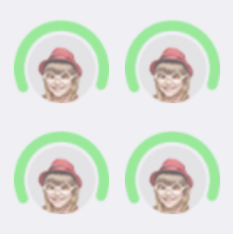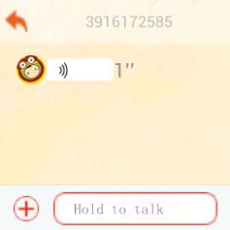
- Security Zone: The smallest radius of the fence is 500m. Break the fence will trigger the alert by sending information to app.
- Setting: click the setting icon in the middle of the bottom, the setting page will display, the following parameters can be set in this page.
1. Set SOS phone number: 3 phone numbers can be set,It will alert after 3S if press SOS key when in emergency situation. Call the 3 phone number periodic. If nobody answer it will be over after two turns.
2. Voice Care(listening phone number): Usually parents' phone number are set as monitor number. When confirmed the watch dial the monitor number,But the watch can not hear any sound from phone. In that way the phone can listen the sound around the watch.
- Operating mode(Working mode): there are 3 working modes, normal mode: 10m/t, every 10 minutes upload information to server; Power save mode: 1h/t, every 1 hour upload information to server; Follow mode: 1m/t, every 1 minute upload information to server.
Please note that the battery using time is according with the working mode, normal mode the battery can be used 1-2 days, power save mode the battery can be used 2-3 days, follow mode the battery only can be used 3-5 hours.
- Profiles: there are 4 profile modes, Vibration and ringing; Ringing; Vibration; Mute; this is the watch notice & alarm mode.
- SMS Alerts: Low voltage remind,SOS, take off device, 3 kind sms alert can be set, when the alert is triggered, sms will be sent to “Guard Number” , the SMS sending will cost normal SMS sending charge.
- Phone Book: Total 15 phone book numbers can be set in the watch. The watch only can call & talk to these 15 numbers, the watch can not call the other numbers. the watch can receive any incoming call.
- Alarm Equipment: The watch can set 3 alarm time, this can notice the children to do something
- Push Switch: If switch on this ,after the watch is took off, the app will receive the alert information.
- Language and time zone: Now the watch display over 10 kinds of language can be selected, they are “English / Chinese / Portuguese / Spanish / Deutsch / Turkiye / Viet Nam / Russian / Francais ”. Also time zone need to be selected, then the watch display time will change to local time, other wise the watch display time will be GMT time (Greenwich Mean Time). Also sending sms to watch can select display language & time zone.
- Remote shutdown: User can remote powered off the watch by app, but the app can not remote power on the watch.
- Restore the default work mode: this will restore the watch back to default work mode (normal mode, every 10 minutes upload information to server).
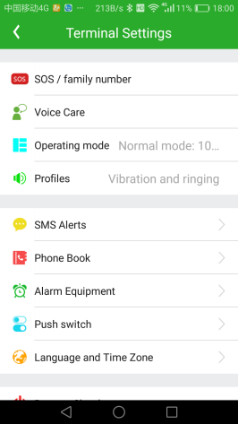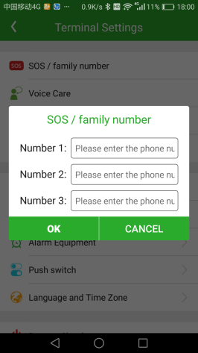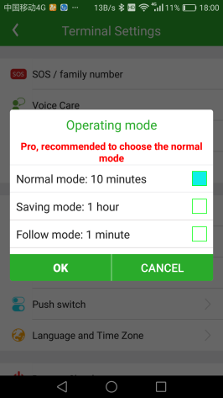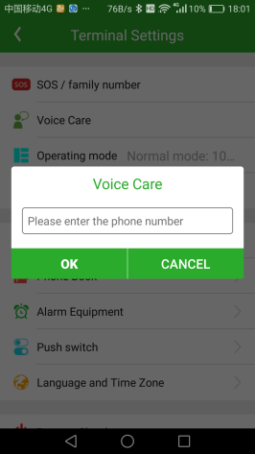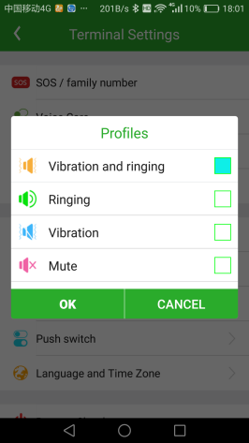
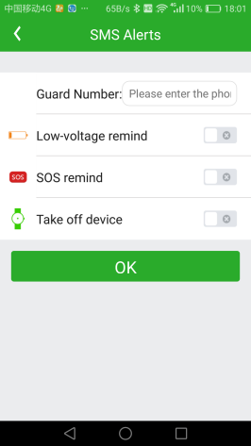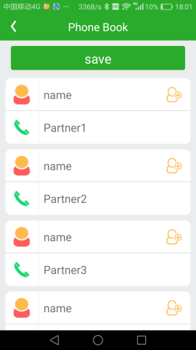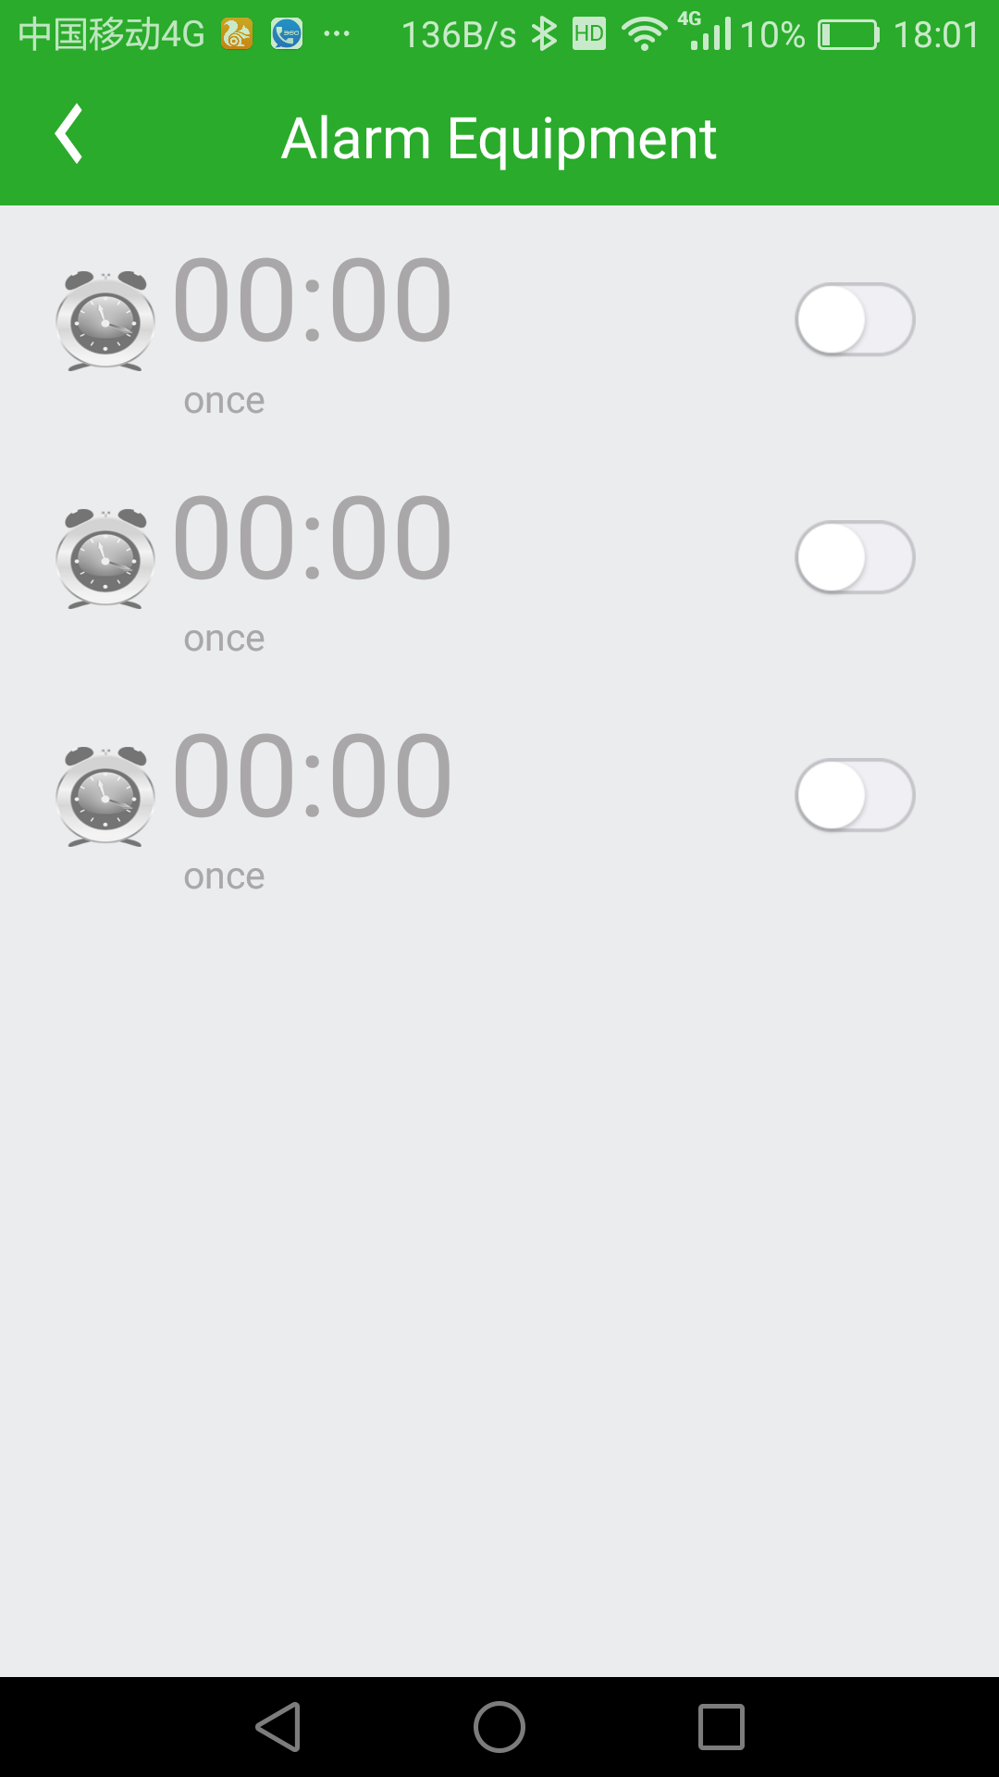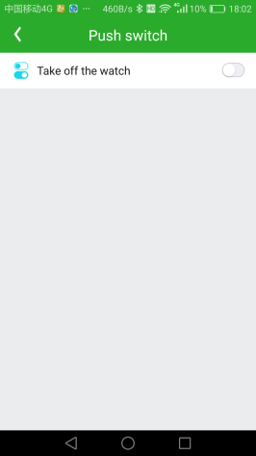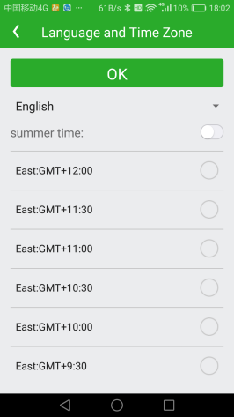
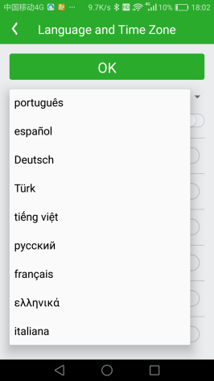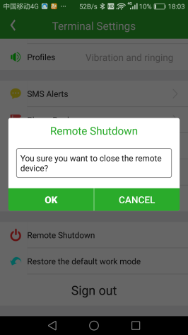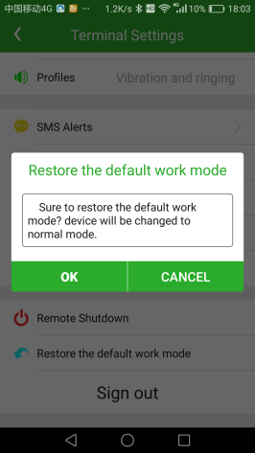

- Locate: Display the latest location, The map menu display the watch and APP mobile phone location. Also the locate method can be display, for example Wifi or GPS or LBS, Click the green change device icon (on the left down corner of the map) can select which watch display the detail location information (if one account have more than 1 watch)
- Locus: In this menu, user can check the watch historical Route, the history data is kept on the server 1 months. User can specify any date in this period, when the LBS is enabled, the tracking maybe is not smoothed.
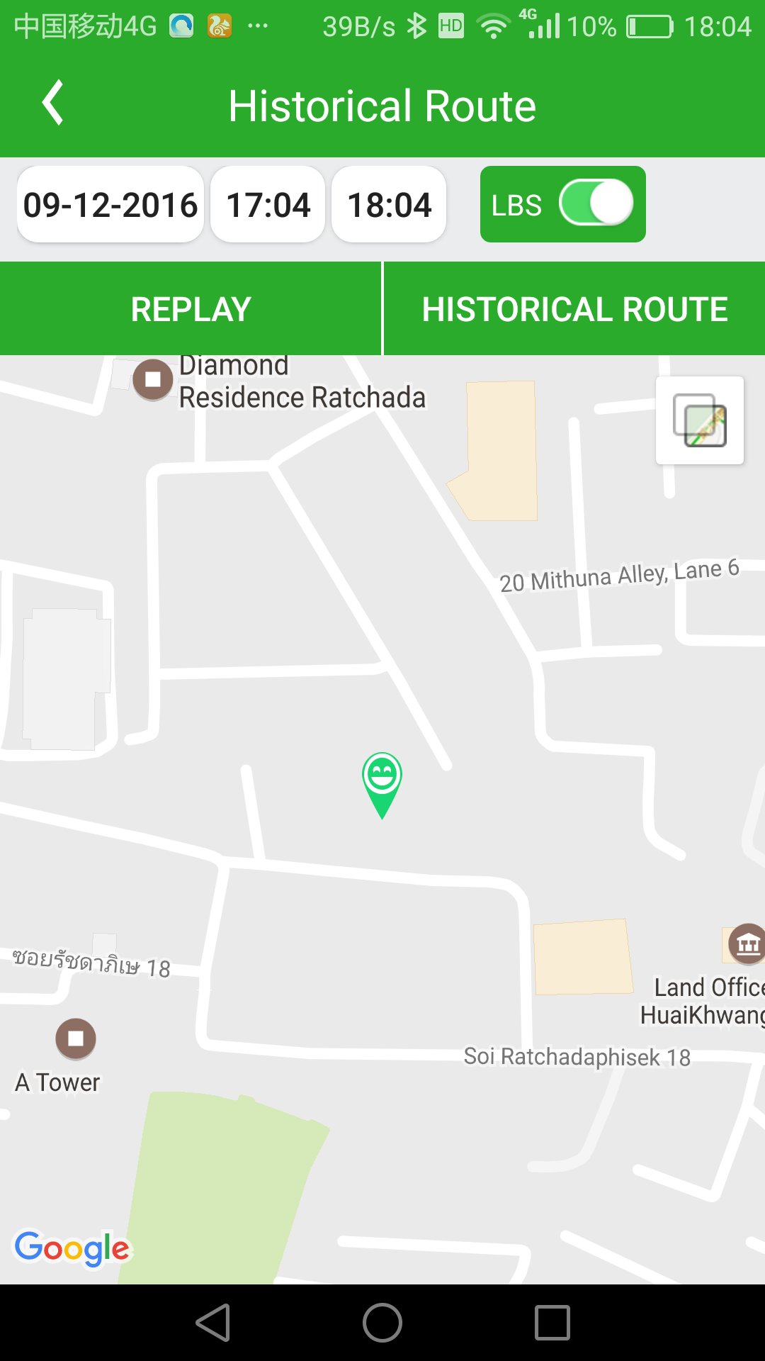

- Click the menu icon on the left top of the map, a menu page will display, the following function and setting can be operated :
Get equipment: Send command to watch to make watch ringing to find where the watch is.
Health: Check health record, like every walk step & distance, sleep rolls etc.
Do Not Disturb Period: Three time period can be set, in these period all calls (Saturday, excluding weekends) can not be called in or called out. This setting can be used to set the class time.
Love Rewards: Parents can send red hearts to children as a reward, the number of red heart will display on the watch.
Alarm-Info: Alarm information center, display received information, for example low power information etc.
SMS Alerts: SMS alert phone number setting, set the low voltage remind & SOS remind phone number, this setting is same with the main setting menu.
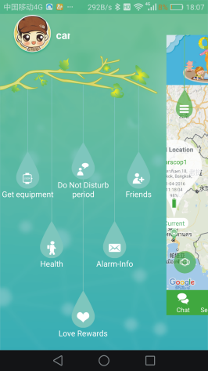
- Click the menu icon on the right top of the map, a menu page will display, the following function and setting can be operated :
Personal: Set the account personal information, like name, phone number, email etc.
Device List: Can add new watch to this account, and also the watch nick name can be changed.
Modify Password: Change the account password.
Suggestion: User can send suggestion to help us improve the app and device better.
Help: Simply using guide.
Sign Out: Logout the current account in the app.

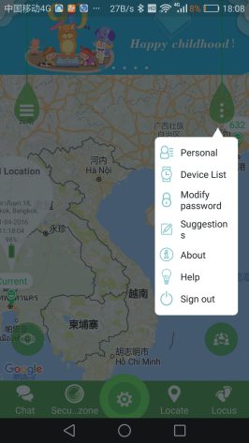

Note: The watch ID is list in the “Device list”, if the watch ID is not correct, the app can not connect the watch and can not receive any information.

Watch Operation & Setting
Watch Main Menu：
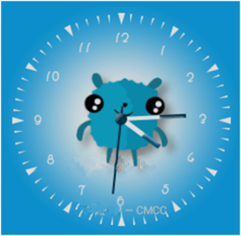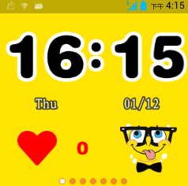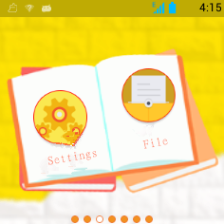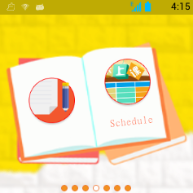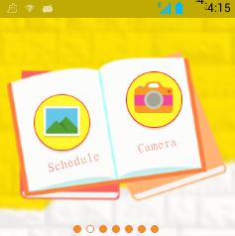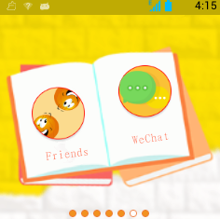

Menu Description：
- Lock screen Display：Week, date, carrier, (missed call).
- Setting: Wifi and network, device, system(date, time, about watch, others, restart).
- File manager: Can read the watch storage status, soft reminder not to delete any documents.
- Phonebook: It stores 15 numbers set by APP, you can choose for dialing.
- Class schedule: Can set or modified by APP to read the school timetable from Monday to Friday.
- Album: Click into review the pictures which taken by the watch, and can be deleted.
- Camera: Click to take photo, while the camera can rotate by 90 degree.
- Kids early education: people recognition, fruit recognition, animal recognition, vehicle recognition. Can simply voice play by Chinese, English.
- Friends: Two watches into this interface, then touch, the 2 watch can add as friends. After adding, the icon will be highlighted. This model can added max. 4 friends. Press a friend profile can chat each other, with voice or pictures. Long press the message can delete or delete all the all message. Long press a friend profile, can delete a friend.
- WeChat: Can send voice message and pictures to app. Please note that the watch cannot send message to app, but app can send message to watch.
- Pedometer: It disabled as default, can turn on in APP. It will automatically count the footstep after turning on. You can read it here, and read the distance, calories, footsteps by sliding the interface.
- Crazy maths: Press start to begin the game, it has 3 levels as simple, normal, difficult.
- Weather: You can read the local city weather.
- Link game: Click start to play.

SOS emergency alert
Long press SOS key for 3 seconds. The watch will enter SOS status, the LCD will display SOS, and the watch will dial 3 SOS numbers 2 times until the calling is answered, also the watch will send SOS alarm information to SOS number by SMS, also the alert information will be sent to APP.
Set Watch Display Language & Time Zone
Send SMS “pw,123456,lz,x,y#” to the watch SIM card number, the “x” is the watch display language(0:English, 1:Chinese, 3:Portuguese, 4:Spanish, 5:Deutsch, 7.Turkiye, 8:Viet Nam, 9 Russian, 10.Francais), y is the time zone, for example NewYork time zone is -5, then z is -5, Tokyo time zone is +9,so the z is 9, the watch time is corrected by GPS time, so normally the watch display time is GMT time, user need set the time zone, and then the watch display time will change to your local time, the time & time zone can be set by app or SMS.
Set Watch SIM Card APN & GPRS Username & Password
This Watch use 2G GSM & 3G WCDMA to visit internet & upload information to internet server, the GPRS APN & GPRS user name & password to visit internet, the APN setting is different for every company SIM card, this watch has preset most of the company APN & GPRS setting, so most of the SIM card will auto configure the APN & GPRS setting, it is not necessary to set again manually, send sms “pw,123456,ts#” can check the watch setting, if the APN & GPRS setting is not right, please send sms to set.
Send SMS “pw,123456,apn,apnname,username,password,mccmnc#” to the watch SIM card number, the “apnname” is the watch SIM card APN, “username” is the GPRS user name, “password” is the GPRS password, “mccmnc” is watch SIM card mcc (Mobile Country Code) and mnc (Mobile Network Code), please call the tracker SIM card mobile phone company hotline to get these settings.
Remove watch alert
There is sensor switch inside watch, It will alert when user remove the watch after 3 minutes wearing. the watch will send alert message to monitor number by SMS (default “off”) & APP.
Battery Voltage Low alert (Low Power Alert)
The watch battery power will display in percentage. When the battery voltage is lower than 20%, the alert message will be sent to monitor number(default “off”) & APP.
Make & Answer & End Call
The watch app can set up 15 phone book numbers, in the phone book menu, sliding can select one of the phone book number, press dial can make a call with the selected number, the watch only can dial any one of these 15 phone book numbers.
Press once “Dial” menu on the LCD screen can answer the calling, and press once (press & release, not long time press) “SOS” button beside can hang up the call.
Check Watch Current Setting
Send SMS “pw,123456,ts#” to the watch SIM card number, the watch will reply the watch current setting by SMS, this command can be used to confirm the setting is right or not when the watch can not work well. The example is as follow:
ver:V1.00_HW_1.10_2016.03.02_16.57.35; :Software version
ID:1413105903; :Watch ID
imei:358614131059038; :Watch IMEI
ip_url:121.43.19.219; :Server IP Address
port:8001; :Server Port
center:; :Main Monitoring Number
slave:; :Slave Monitoring Number
sos1:; :SOS number 1
sos2:; :SOS number 2
sos3:; :SOS number 3
profile:1; :Working mode 1
upload:60S; :Upload Time Interval 60 Seconds
bat level:86; :Battery Power 68%
language:0; :Display Language:0 English
zone:-5.00; :Time Zone:-5 (NewYork Time)
GPS:NO(0); :GPS Satellite
GPRS:OK(52); :GPRS Signal Strength
pw:123456; :Watch Password:123456

Trouble Shooting
  - After power on the watch, call the watch, no response, and no ring, please confirm the SIM card has been installed properly, please note the direction, and the SIM card has enough money, and the mobile phone can work well in that place.
  - Please confirm the watch SIM card GPRS data service is enabled, some SIM card need send sms or USSD command to enable the data service.
  - This watch use 2G GSM & 3G WCDMA network, and it upload tracking only through 2G & 3G network , some 4G SIM card have 2G GSM& 3G WCDMA network, this kind of SIM card can be used in this watch.
  - The tracking data on our server will keep 1 months, the old data will be deleted.
  - If the watch can not upload location to website, please confirm the watch SIM card APN or GPRS username & password is right, please send sms “pw,123456,ts#” to check the watch setting, call the watch SIM card mobile phone company hotline to confirm the APN & GPRS username and password are right.
  - If the watch can not send back information by SMS, please confirm the SIM card has ID caller display function and SMS service function, and you have set the center or slave center number (only center or slave center number can send SMS), and please read the SMS information of the watch sending back, and check the instruction & password is right or not.
  - Can not login the platform: please contact your dealer to reset the account password.
  - After go out the under ground park, some tracking maybe lost, the GSM and GPS module will take a few minutes to receive signal and re-locate, some tracking maybe lost, this is normal.
  - Some time the location is not very precise, because this watch use GPS + LBS + Wifi to locate the watch, for GPS locating is very precise, the precision can reach 5-10 meters, but in some place, no GPS signal can be received, for example underground park or indoor room or close to high building, the LBS locating & Wifi locating precision only can be 50-100 meters, in the country side, the locating precision maybe over 500 meters, this is not the problem of the watch, this is caused by the network.

Specification:
GSM Module | MTK | GPS Module | MTK
GSM Frequency | 850/1900Mhz (Dual Band) | WCDMA Frequency | 900/2100Mhz (Dual Band)
GSM WCDMA / GPS Antenna | Built in | Locate precision | 5-10 Meters
GPS Cold Start Time | 23 seconds | GPS Hot Start Time | 1 second
Working Voltage | 5V DC | Recharging Current | < 5V/400mA
Standby Current | < 10 mA | Uploading Current | <150mA / 5V
Battery | 600mAh | Working Temperature | -20 ⁰C to +55 ⁰C
Absolute Temperature | -35 ⁰C to +70 ⁰C | Storage Temperature | -40 ⁰C to +80 ⁰C

Warranty
This system has been tested before sold. We strongly recommend you to get this system installed by professional. There is a one-year warranty except the following condition:
1. Installed, fixed, or changed by personally or unprofessional.
2. Warranty will eliminate if the ownership of the tracker has been changed.
3. Parts damaged by man-made.
4. Battery, adapter, wires, etc.
Warning: this device is just a auxiliary product that applying the location of current object, we have not any responsibility if you have damage or lost in using this tracker.
Customer
User Mobile Phone |  | Tracker SIM card
Date | Year month day
Model | CCTR-632 | Serial Number
Distributor
Notes: The explanation of this manual is belonged to our company, some small changes may not notice customer, if you have any problem please contact us, thanks !

