CCTR-631 GPS Watch Tracker User Manual ---V1-201512
Welcome to use this mini GPS watch tracker. This product is with GPS, GSM & wifi module, that has many new and unique functions, such as super power saving technology, LBS & Wifi locate technology (without GPS signal), real time uploading current location to server (user can control working mode), check current location or playing back history tracking on website or mobile phone etc. It contains high capacity rechargeable polymer battery (400mAH), working time can reach 1-2 days (10 minutes upload interval), This GPS watch is mini size, and easy to use, it is suit for kids, old parents, pets and outdoor workers tracking.
This tracker also have LBS locating (mobile phone base station CELL ID) & public wifi locating function, if no GPS signal in some place, such as underground park, indoor room, or around high building with bad GPS signal, the tracker will locate with LBS or wifi (the LBS or wifi locating precision is about 50-500m in the city, and the GPS locating precision is about 10m).
Using app you can check the current location & history track max to 3 months, the geo-fence alarm and working mode & other setting can be set on app, user register on the app with the watch ID, user name can be defined by user, the default server is HongKong server, user can ask the distributor to move the watch to your local server (HongKong / Europe Africa / Asia Oceania / South America / North America). Visit the following website or scan the following QR code can download and install the app.
http://www.igps.info/gpswatch

iPhone App Download & Install Android App Download & Install
Scan the following QR code or click the following link can download or read online the manual in Word or Pdf format.
Word Version: http://www.igps.info/en/cctr-631-gpstracker-en-v1.doc
Pdf Version: http://www.igps.info/en/cctr-631-gpstracker-en-v1.pdf

Manual Word Version QR Code Manual Pdf Version QR Code

Product:
CCTR-631 Watch 1 set (Case A or B, only case different), Mini USB Charging Wire, Manual (CD or Print).
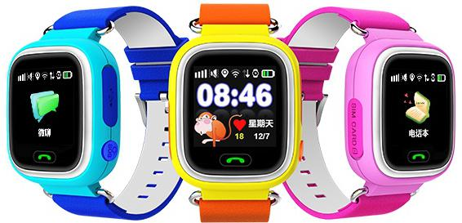
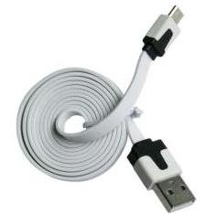
Charging

SIM
SOS

Back
Talking

CCTR-631-B GPS Watch USB Charging Wire
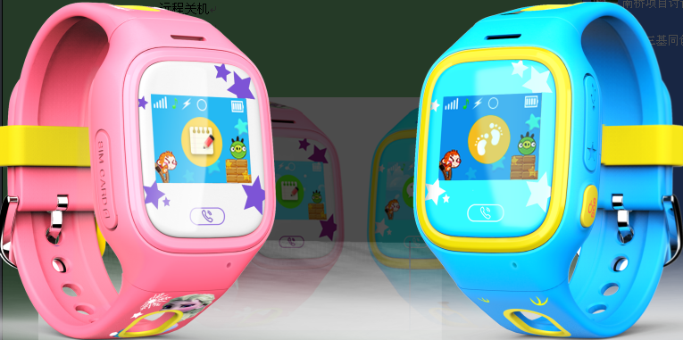
Charging

SIM Card
Back
Talking

SOS

CCTR-631-A GPS Watch
Function Specification:
- GPS+LBS+Wifi 3 ways to locate.
- Fashion Color LCD with touch panel.
- Working time can reach 1-2 days.
- Listen / SOS / Geo-fence alarm.
- Make a call in Phone Book (15 numbers).
- Chat talking function.
- SOS alarm by calling & SMS.
- Watch timer alarm.
- Remove watch alarm.
- Health walking pedometer.
- Life time free platform service charge.
- History tracking data will keep 3 months on server.
- GSM 850/900/1800/1900 global GSM frequency.
- Low battery alarm by SMS.
- App multi-language can be selected (English, Portuguese, Spanish, German, Thai, Turkish, Vietnamese, Russian, French, Indonesian, Malay, Arabic, Dutch, Danish, polish, Greek, Italian, Swedish, Hungarian language, Filipino.)
- Watch language can be selected (English / Chinese / Portuguese / Spanish / Deutsch / Turkiye / Viet Nam / Russian / Francais).
- World wide local server can be selected (Europe Africa / Asia Oceania / South America / North America)

Display Description
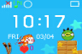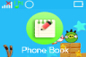


- 1 Home page: The first line of small icons were gsm signal, ringing mode, networking flag, location icon, symbol voice(not shown), light perception flag, flag battery, below the time, date, Love.

- 2 The phone book: Click to go to see the 15 phone book numbers settings by app, click to dial and make a call, the watch only can dial this 15 numbers in the phone book.
- 3 Micro-chat: Point into the micro-chat app that send voice phone.
- 4 make Friends: In the interface, the watch can add a same watch as friend by closing to each other, the the watch can only add one friend. After being friends, the watch can talk to each other by micro talk.
Replace Friends: After watch make a friend,only app can deletes the current friends, and then watch can add another watch as new friend.
- 5 Pedometer: Default pedometer is off, need to enable in the app, after pedometer is enabled, the pedometer data can be seen on the screen when the LCD is ON.
- 6 Scan it: The interface is QR code of the ID, visit the http://www.igps.info/gpswatch to download & install app, add the device by input the ID number into the app also can add the watch the device list.
- 7 Recording: Micro interface into a long chat after sending recordings by mobile phone app; click Bumper dating dating after watches also come in audio interface, Send to a friend watch after recording.

Before Using:
1. Power On/Off
Power On: Press and hold the Button SOS over 3 seconds and then the LCD will display “HELLO”, then release the button ,and the GPS watch is powered ON.
Power Off: If the GPS watch is powered ON, and the SIM card is not installed, press the SOS button over 3 seconds, the watch will display “BYE BYE” and power off. If the SIM card is installed, the watch can not be power off by pressing the SOS button, it is only can be power off by app, also the watch will power off automatically after battery exhausted.
- SIM Card Installation(Micro card): This GPS watch need a micro SIM card (every month need about 10M GPRS data according the different working mode, order an data package can save money), Open the SIM card slot rubber cover with finger, push the SIM card in the slot by the following diagram direction, please note the direction of the metal contact pin and the bevel of the SIM card. After the SIM card is installed properly, you can hear a “Di Da” sound. Press the SIM card in the SIM card slot, the SIM card will come out a little, and then the SIM card can be pull out.
Note: Please power off the watch before install or unstall the SIM card (If the watch work properly with SIM card, only app can power off the tracker).
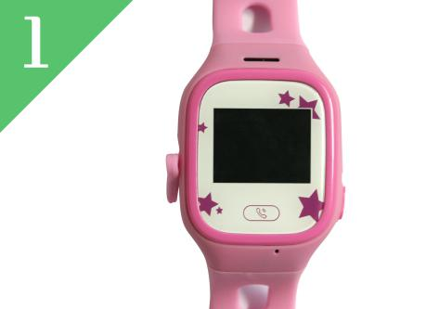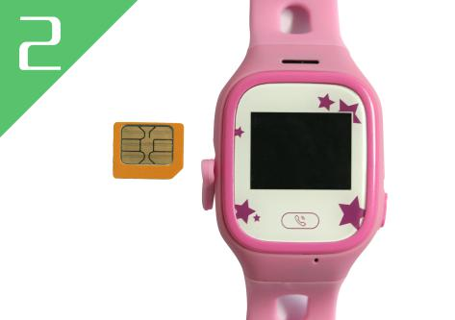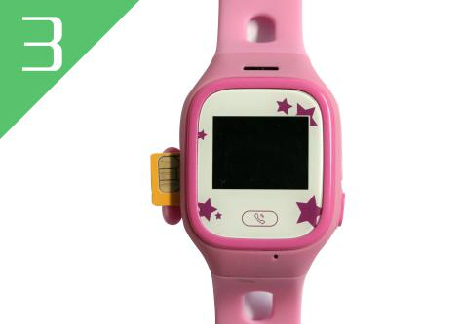
Note:
- This GPS watch use 2G GSM network, and it upload tracking only through GPRS, it can not work in CDMA network or 3G(WCDMA or CDMA2000) network. (Some 3G & 4G SIM card can use in 2G GSM network, this kind of 3G & 4G SIM card can be used in this tracker)
- This GPS watch use micro SIM card (Cut the standard SIM card can get Micro SIM Card, this SIM card size is same with iPhone 4/4S, not the iPhone 5/5S/6/6S Nano SIM Card).
- Enable the SIM card GPRS data service and Caller ID Function (Some card maybe need using mobile phone to send SMS to service hot line to enable the GPRS data service).
- Before installing or uninstalling the SIM card, please power off the tracker.
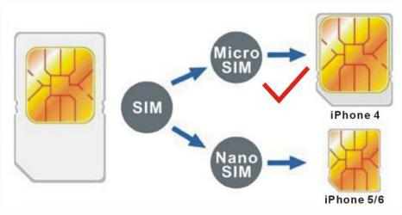
3. Low Battery Alarm
When the tracker battery voltage is low than 20%, the watch will send battery low information SMS to the authorized phone number. maybe a few hours later, the watch will turn off after the battery is gone out.
4. Recharging
This GPS watch uses the 5V DC voltage to recharge, connect the watch charging micro USB socket to the AC charger or PC USB, the GPS watch will begin to recharge, about 2-3 hours, the battery will be full, press once any button of the GPS watch tracker, the LCD will display the battery level.
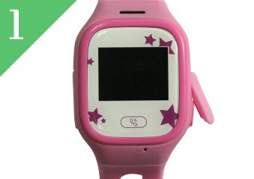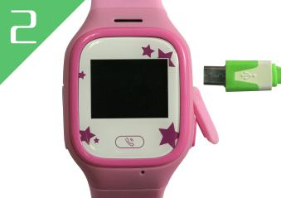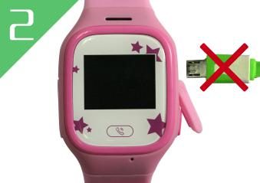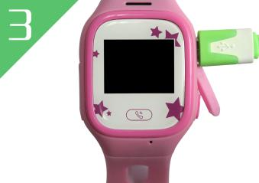
5、GPS & GSM Antenna
The Antenna of GSM and GPS are built in the GPS watch.if can not locate please change a place to try again.
6、About Water-proof
This watch is not water-proof, but it can resist the water splash, but can not be in the raining or drop in the water.
7. Using Condition
The working temperature is -20℃ to 60℃, over this range the specification maybe can not reach the standard level. the storage temperature can reach to -40℃ to 80℃.

Simply Using Step
- First to buy a 2G GSM phone SIM card and enable GPRS service, order a data package (Normally will use about 10M GPRS data every month), install in the tracker, please refer the above Before Using 2.
- Press any SOS button till the watch power on, first time using please put the tracker outdoor for easy get GPS & GSM signal.
- Press SOS button once, the LCD will display, if the time change to GMT time, it means the GPS locate is normal.
- Using mobile phone to visit website : www.igps.info/gpswatch to download & install app, register the app user name (the default server is HongKong server), and then add the watch ID the device list.
- Clip the Map in the app to check the watch is online or not.
- Set the app setting by the following description,please refer APP Register & Operation.
- Send SMS “pw,123456,lz,x,y#” to tracker to set your local time and language, please refer Watch Operation & Setting 2.
- This tracker can auto download & configure APN & GPRS user name & password, if the auto configure is not right, the tracker can not upload location to server, then you need send SMS to tracker to change the APN & GPRS manually, send “pw,123456,ts#” to the tracker can check the tracker setting, call the tracker SIM card supplier to confirm the APN & GPRS is right, please refer Watch Operation & Setting 4 to set APN & GPRS username and password.
- If the tracker need change the server, please send sms to change IP, please refer Watch Operation & Setting 3.

App Register and Operation

1. APP register
Before logging in, register the account first with watch ID, enter the 15 registration code(print on the back of the watch, also can be check in the watch menu) number and account name (Named by user), nick name , personal mobile phone, password, and then click “OK” to register, the registation code is unique and can not re-registered, the corresponding ID number & account must be unique; reset password required registration code, login account and the registration phone number. the registration interface as shown below.
Please use the proper server: Default we use “HongKong” server, before moving to new server, the administrator need add the watch ID to the new server first, if user select wrong server, the app can not control the watch or receive any information.
2. APP Log in
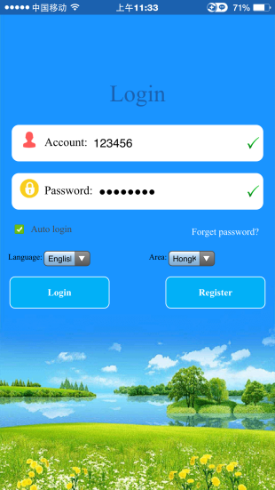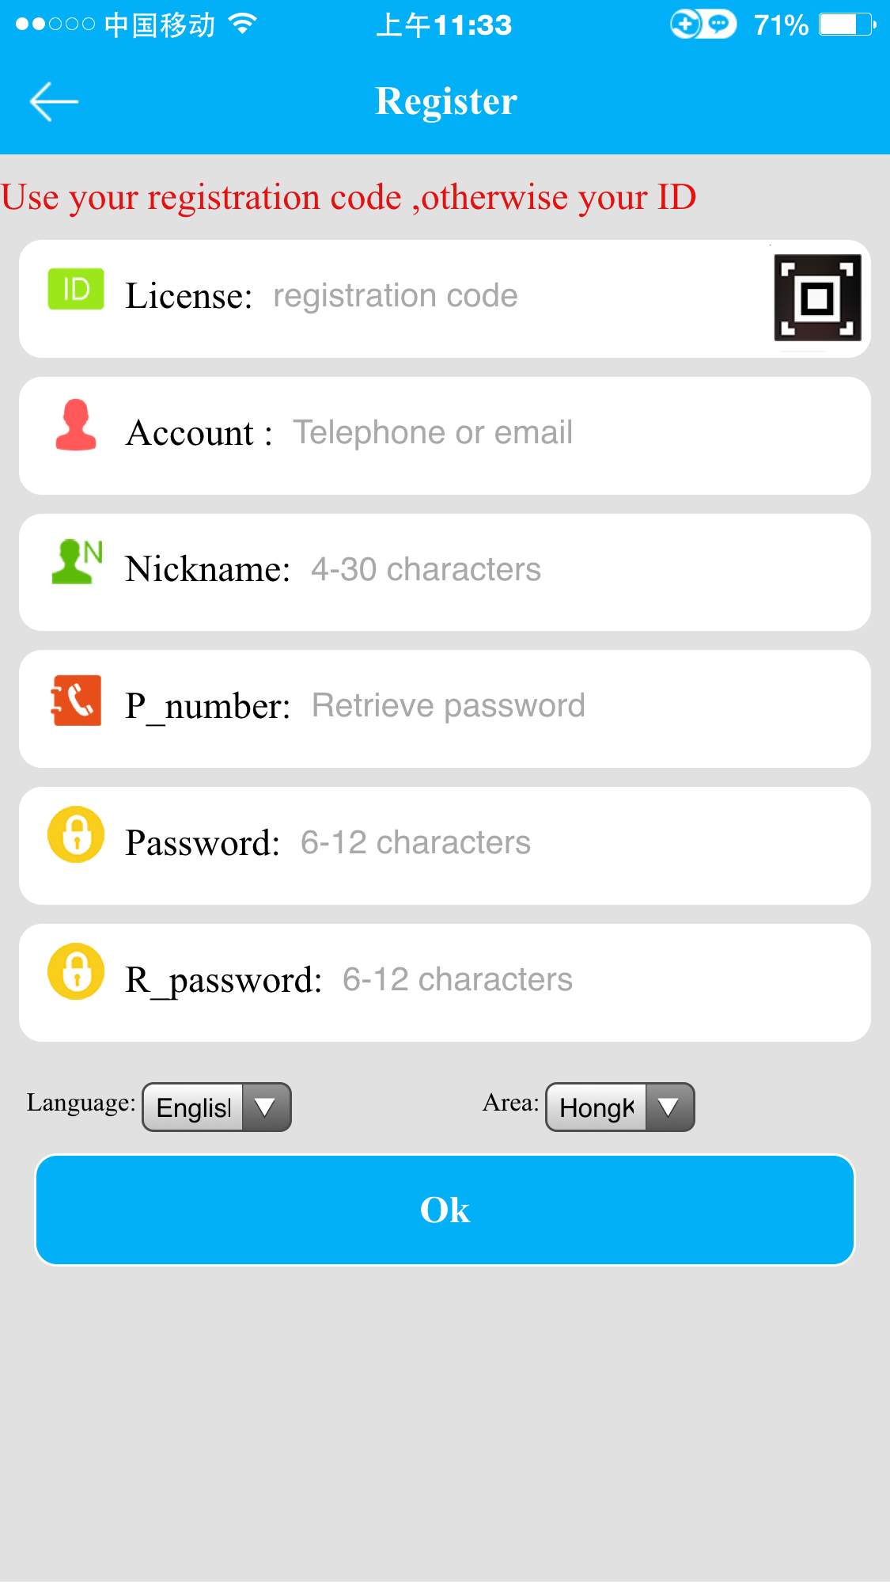
3. APP “Home” Menu
After finish register, input the correcter account number and password, click login, enter the main menu. The main menu (Home Menu Display) show as below:
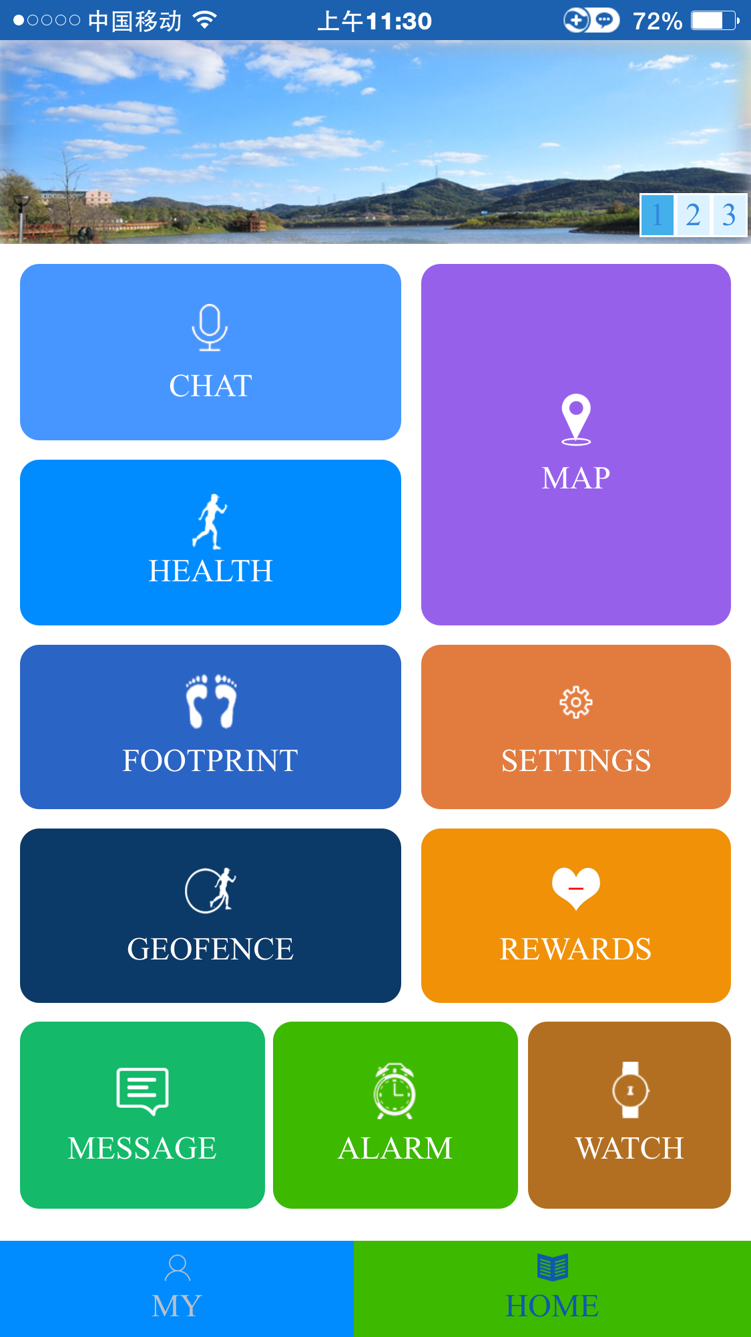
Function instruction:
- Intercom: Watch talk to mobile phone
App send voice to watch: After turn on record function. App start to record and sent to watch. The longest voice can be 15s. The watches into the chat interface short press to play the voice box.
Watch send voice to app: Enter the micro-chat screen, press the intercom icon recording(The longest record time is 15s), release the recording sent to app; If the watch has add a friend, enter the “Make Friend” menu, pressing “Record” menu can record sound and send to friend watch.
- Map:Real-time check the watch latest location
The map menu display the watch and APP mobile phone location. If the “location” menu is click in the Map Menu, the watch will begin 3 minutes real time locate, the interval time for upload is 20s. After 3 minutes it will back to the default work mode. The location icon color is different by different locate method, if the location icon is red means it is GPS locating, if the location icon is Yellow means it is LBS locating, if the location icon is Green means it is WIFI locating.
- Setting: Parameters setting for watch
1. Set SOS phone number: 3 phone numbers can be set,It will alert after 3S if press SOS key when in emergency situation. Call the 3 phone number periodic. If nobody answer it will be over after two turns.
2. Monitoring: Usually parents' phone number are set as monitor number. When confirmed the watch dial the monitor number,But the watch can not hear any sound from phone. In that way the phone can listen the sound around the watch.
3. Work mode: there is 3 working mode, normal mode: 10m/t, every 10 minutes upload information to server; Power save mode: 1h/t, every 1 hour upload information to server; Follow mode: 1m/t, every 1 minute upload information to server. Please note that change the working mode
4. Do not disturb: three time period can be set, in these period all calls (Saturday, excluding weekends) can not be called in or called out.
5. SMS alert setting: Low voltage,SOS, watch removal, 3 kind sms alert can be set, when the alert is triggered, sms will be sent to “Guardian Number” (Default this number is same with Monitoring number), the SMS sending will cost normal SMS sending charge.
6. Touch your friends: Add a watch as friend, watch can send voice to friend.
7. Telephone: Total 15 phone book numbers can be set in the watch. The watch only can call & talk to these 15 numbers, the watch can not call the other numbers. But the watch can receive any incoming call.
8. Language and time zone: Now the watch display 10 kinds of language can be selected, they are “English / Chinese / Portuguese / Spanish / Deutsch / Turkiye / Viet Nam / Russian / Francais ”. Also time zone need to be selected, then the watch display time will change to local time, other wise the watch display time will be GMT time (Greenwich Mean Time). Also sending sms to watch can select display language & time zone.
9. Push Switch: Turn on the switch, after the watch is took off, the app will receive the alert information.
10. Contextual mode: Watch have 4 incoming call ringing modes, Vibration & ring the bell ; Ring-down;Vibration;Silence.
11. Remote shutdown: After the SIM card is installed to watch, and the watch work well, the watch can not be powered off by pressing the “SOS/Power” key, it is only can be remote powered off by app.
12. Restore the default work mode: this will restore the watch back to default work mode (normal mode, every 10 minutes upload information to server).

- Health: Enable the pedometer can report every day walk step & distance, please note that the Calorie is is only a reference data.
- Footprint: In this menu, user can check the watch history tracking, the history data is kept on the server 3 months.
- Geofence: The smallest radius of the fence is 500m. Break the fence will trigger the alert by sending information to app.
- Reward: Parent can send red hearts to children as a reward, the number of red heart will display on the watch.
- Alarm: The watch can set 3 alarm time, this can notice the children to do something.
- Watch: This command is used to finding where is the watch, after sending the command, the watch will ring so that user can find the watch, press the talk key can stop the ringing.
- Message: This is the app receiving message like alarm information & alert.

4. APP “MY” Menu
In the “Home” menu, click the “MY” menu will go to my account menu, in this menu, user can set personal data, add or delete watch ID, change account password. Also the seconds watch ID can added to the account , so that one account can check 2 watches.
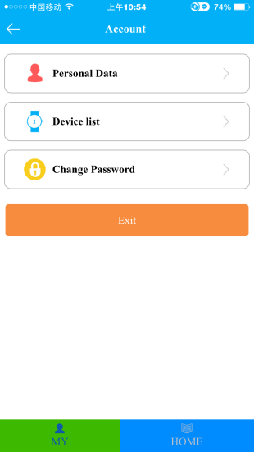
Note: The watch ID is list in the “Device list”, if the watch ID is not correct, the app can not connect the watch and can not receive any information.

Watch Operation & Setting
1. Watch SOS emergency alert
Long press SOS key for 3 seconds. The watch will go to SOS status, the LCD will display SOS, and the watch will dial 3 SOS numbers 2 times until the calling is answered, also the watch will send SOS alarm information to SOS number by SMS, also the alert information will be sent to APP.
2. Set Watch Display Language & Time Zone
Send SMS “pw,123456,lz,x,y#” to the watch SIM card number, the “x” is the watch display language(0:English, 1:Chinese, 3:Portuguese, 4:Spanish, 5:Deutsch, 7.Turkiye, 8:Viet Nam, 9 Russian, 10.Francais), y is the time zone, for example NewYork time zone is -5, then z is -5, Tokyo time zone is +9,so the z is 9, the watch time is corrected by GPS time, so normally the watch display time is GMT time, user need set the time zone, and then the watch display time will change to your local time, the time & time zone can be set by app or SMS.
3. Set Watch SIM Card APN & GPRS Username & Password
This Watch use 2G GSM GPRS to visit internet & upload information to internet server, the GPRS APN & GPRS user name & password to visit internet, the APN setting is different for every company SIM card, this watch has preset most of the company APN & GPRS setting, so most of the SIM card will auto configure the APN & GPRS setting, it is not necessary to set again manually, send sms “pw,123456,ts#” can check the watch setting, if the APN & GPRS setting is not right, please send sms to set.
Send SMS “pw,123456,apn,apnname,username,password,mccmnc#” to the watch SIM card number, the “apnname” is the watch SIM card APN, “username” is the GPRS user name, “password” is the GPRS password, “mccmnc” is watch SIM card mcc (Mobile Country Code) and mnc (Mobile Network Code), please call the tracker SIM card mobile phone company hotline to get these settings.
4. Remove watch alert
There is sensor switch on watchband. It will alert when user remove the watch after 3 minutes wearing. the watch will send alert message to monitor number by SMS (default “off”) & APP.
5. Battery Voltage Low alert (Low Power Alert)
The watch battery power will display in percentage. When the battery voltage is lower than 20%, the alert message will be sent to monitor number(default “off”) & APP.
6. Micro-chat
The watch enter the micro chat menu can send voice to added friend.
7. Phone Book
The watch app can set up 15 phone book numbers, in the phone book menu, sliding can select one of the phone book number, press dial can make a call with the selected number, the watch only can dial any one of these 15 phone book numbers.
8. Answer & End Call
Press once “Dial” menu on the LCD screen can answer the calling, and press once (press & release, not long time press) “SOS” button beside can hang up the call.
9. Check Watch Current Setting
Send SMS “pw,123456,ts#” to the watch SIM card number, the watch will reply the watch current setting by SMS, this command can be used to confirm the setting is right or not when the watch can not work well. The example is as follow:
ver:V1.00_HW_1.10_2016.03.02_16.57.35; :Software version
ID:1413105903; :Watch ID
imei:358614131059038; :Watch IMEI
ip_url:121.43.19.219; :Server IP Address
port:8001; :Server Port
center:; :Main Monitoring Number
slave:; :Slave Monitoring Number
sos1:; :SOS number 1
sos2:; :SOS number 2
sos3:; :SOS number 3
profile:1; :Working mode 1
upload:60S; :Upload Time Interval 60 Seconds
bat level:86; :Battery Power 68%
language:0; :Display Language:0 English
zone:-5.00; :Time Zone:-5 (NewYork Time)
GPS:NO(0); :GPS Satellite
GPRS:OK(52); :GPRS Signal Strength
pw:123456; :Watch Password:123456

Trouble Shooting

  - After power on the watch, call the watch, no response, and no ring, please confirm the SIM card has been installed properly, please note the direction, and the SIM card has enough money, and the mobile phone can work well in that place.
  - Please confirm the watch SIM card GPRS data service is enabled, some SIM card need send sms or USSD command to enable the data service.
  - This tracker use 2G GSM network, and it upload tracking only through 2G GPRS, some 3G & 4G card have 2G GSM network, this kind of SIM card can be used in this tracker.
  - The tracking data on our server will keep 3 months, the old data will be deleted.
  - If the watch can not upload location to website, please confirm the watch SIM card APN or GPRS username & password is right, please send sms “pw,123456,ts#” to check the watch setting, call the watch SIM card mobile phone company hotline to confirm the APN & GPRS username and password are right.
  - If the watch can not send back information by SMS, please confirm the SIM card has ID caller display function and SMS service function, and you have set the center or slave center number (only center or slave center number can send SMS), and please read the SMS information of the watch sending back, and check the instruction & password is right or not.
  - Can not login the platform: please contact your dealer to reset the account password.
  - After go out the under ground park, some tracking maybe lost, the GSM and GPS module will take a few minutes to receive signal and re-locate, some tracking maybe lost, this is normal.
  - Some time the location is not very precise, because this watch use GPS + LBS + Wifi to locate the watch, for GPS locating is very precise, the precision can reach 5-10 meters, but in some place, no GPS signal can be received, for example underground park or indoor room or close to high building, the LBS locating & Wifi locating precision only can be 50-100 meters, in the country side, the locating precision maybe over 500 meters, this is not the problem of the watch, this is caused by the network.
Specification:
GSM Module | MTK | GPS Module | MTK
GSM Frequency | 850/900/1800/1900Mhz (4 Band) | GPS channel | 24 channels
GSM / GPS Antenna | Built in | Locate precision | 10-20 Meters
GPS Cold Start Time | 36 seconds | GPS Hot Start Time | 1 second
Working Voltage | 5V DC | Recharging Current | < 5V/400mA
Standby Current | < 10 mA | Uploading Current | <150mA / 5V
Battery | 400mAh | Working Temperature | -20 ⁰C to +55 ⁰C
Absolute Temperature | -35 ⁰C to +70 ⁰C | Storage Temperature | -40 ⁰C to +80 ⁰C

Warranty
This system has been tested before sold. We strongly recommend you to get this system installed by professional. There is a one-year warranty except the following condition:
1. Installed, fixed, or changed by personally or unprofessional.
2. Warranty will eliminate if the ownership of the tracker has been changed.
3. Parts damaged by man-made.
4. Battery, adapter, wires, etc.
Warning: this device is just a auxiliary product that applying the location of current object, we have not any responsibility if you have damage or lost in using this tracker.
Customer
User Mobile Phone |  | Tracker SIM card
Date | Year month day
Model | CCTR-631 | Serial Number
Distributor
Notes: The explanation of this manual is belonged to our company, some small changes may not notice customer, if you have any problem please contact us, thanks !

